UIT DIE PEN VAN DIE CEO (1/19)
(Volg my op Twitter justchad_cga)

Justin Chadwick 4 Januarie 2019
“Those who say it can not be done, should not interrupt those doing it” Chinese Proverb

MOENIE 2019 CGA SITRUS SUMMIT MISLOOP NIE
Drie belangrike internasionale sprekers sal van 12 tot 14 Maart 2019 by die CGA Sitrus Summit, wat by die Boardwalk Konferensiesentrum in Port Elizabeth gehou word, (besoek www.cga.co.za) referate lewer. Prof Marcos Neves word wyd beskou as die kenner op die gebied van waardekettings. Afkomstig van Brasilië, het Prof Neves aansienlike werk in die sitrusbedryf gedoen en hy het baie oor die sitrusvoorsieningsketting geskryf. Philippe Binard is van altyd af in die Europese vrugtebedryf betrokke. As “general delegate” van Freshfel (wat EU-invoerders en uitvoerders verteenwoordig), het Philippe baie ervaring oor regeringsbeleide, statistieke oor handelsvloei en die kompleksiteit van handel met die EU. Philippe se aanbieding sal die globale sitrus situasie dek, en wat dit alles vir Suider-Afrika se sitrusbedryf beteken. Richard Bright se Reefer Trends word wyd gelees en as 'n leier in die maritieme wêreld erken. Met Suid-Afrika se sitrusvolumes wat toeneem en uitdagings in terme van koste en beskikbaarheid van langafstandhandel wat toeneem, sal Richard insig gee oor wat in die toekoms verwag kan word.
Om nie deur die internasionale aanbieders oorskadu te word nie, sal ons ook nasionale talent teenwoordig hê. John Purchase “has become a word of reason” en 'n bron van kalmte, aangesien landbou baie uitdagings ondervind. In die politieke voorspraakruimte beteken die teenwoordigheid van John op hoëvlakbesprekings dat 'n beredeneerde benadering geneem word. John sal sommige van die dringende regeringsvereistes wat die sitrusbedryf raak, bespreek. En dan het ons die bekroonde Wandile Sihlobo - as 'n landbou-ekonoom het Wandile in 'n baie kort tyd na die top in sy veld gestyg. Peter Schlebusch van Standard Bank sal afgevaardigdes met ‘n paar “pointers” met betrekking tot die ekonomie voorsien. Die CGA Summit sal sommige van die kritiese (en soms sensitiewe) onderwerpe wat Suider-Afrika se sitrusbedryf in die gesig staar, bespreek. Die bedreiging van HLB (Asiatiese Vergroening) is een wat opkom - dit sal deur Vaughan Hattingh bespreek word. Werkersregte is 'n ander - Retha Louw (SIZA) sal sommige van die hulpmiddele wat vir die produsente beskikbaar is, bespreek, terwyl lewensevarings deur 'n paar sitrusprodusente gedeel sal word. Die uitdagings en geleenthede wat deur swart produsente in Suid-Afrika ondervind word, sal in een van die sessies behandel word. 'n Paneel sal ook markontwikkeling bespreek - 'n onderwerp wat tydens die 2017-Summit bespreek is en steeds 'n onderwerp van debat is. Die CGA se verteenwoordigers in die VSA, Rusland en die EU sal ook beskikbaar wees om oor die nuutste ontwikkelinge te praat.

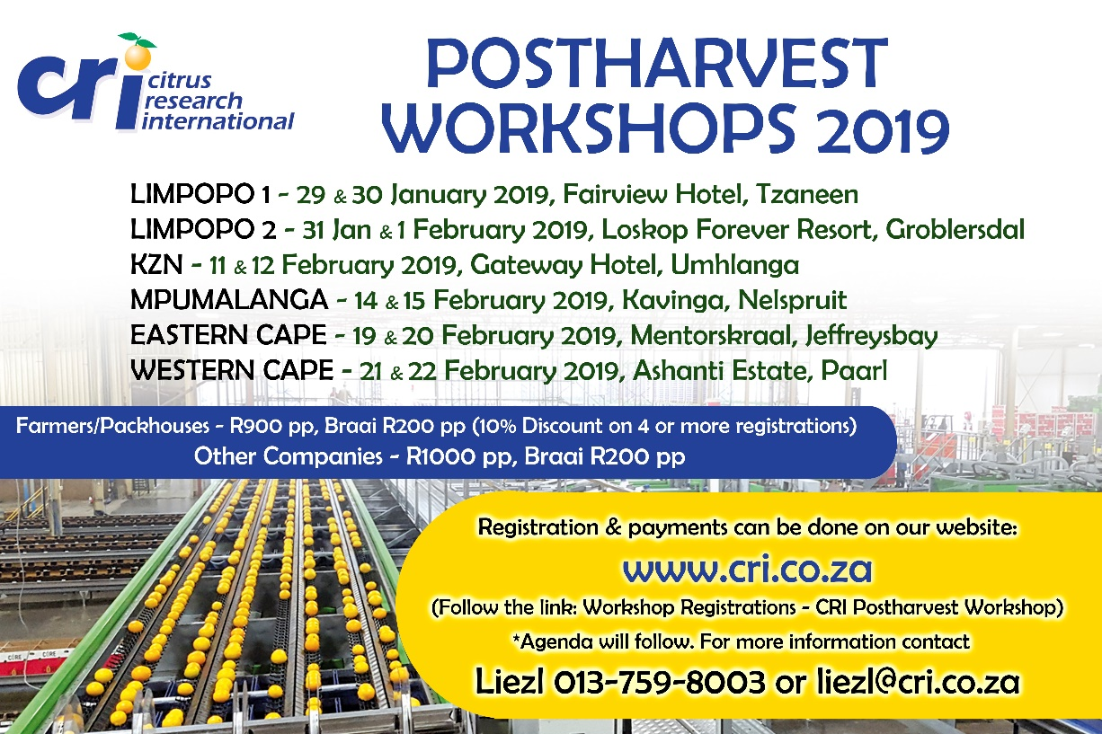

DIE CGA GROEP MAATSKAPPYE (CRI, RIVER BIOSCIENCE, XSIT, CGA CULTIVAR COMPANY, CGA GROWER DEVELOPMENT COMPANY & CITRUS ACADEMY) WORD DEUR SUIDER-AFRIKA SE SITRUSPRODUSENTE BEFONDS

