UIT DIE PEN VAN DIE CEO (42/18)
(Volg my op Twitter justchad_cga)

Justin Chadwick 19 Oktober 2018
“There is no trade-off between social inclusion and a country’s level of competitiveness” Saadi Zahidi, WEF

2018 POMELO SEISOEN SE OORSIG
Die gordyn het oor 2018 se pomelo-seisoen gesak en dit was 'n rekord in terme van die volume wat vir uitvoer gepak is. Die 16,4 miljoen 17 Kg kartonne wat gepak is (279 000 ton) oortref die 2013 volume van 16,1 miljoen kartonne. Om die 2018 pomelo-oes te skat, was 'n uitdaging vir baie van die lede van die Pomelo-fokusgroep. Die aanvanklike skatting was 14.845 miljoen kartonne - die finaal is bykans 11% oor die skatting. Binne hierdie skattings was sommige VFG-lede ver van die kol (Limpoporivier het 29% meer as skatting gepak,
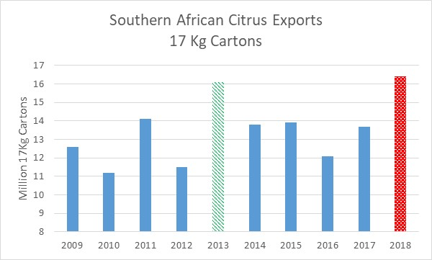
Letsitele 26%). Ander was binne die aanvaarbare 10% verskil - Onderberg 8% oor terwyl die Oranjerivier 6% onder die skatting was. Nkwalini was 31% onder die skatting. Alhoewel die finale resultate in terme van verdienste uit pomelo’s eers in die nuwe jaar bekend sal wees, dui bewyse op ‘n moeilike bemarkingsjaar.
Nederland bly die wêreldleier in terme van die invoer van Suider-Afrika se pomelo's – voer rondom 70 000 ton (2017 63 000 ton) in. Die groot nuus in die pomelo-wêreld is die opkoms in uitvoere na China - van 20 000 ton in 2017 tot 51 000 ton in 2018. Hierdie plaas China in die tweede plek in terme van suider-Afrika se pomelo-uitvoere, met Japan nou in die derde plek op 35 000 ton. Rusland (17 000 ton) en die VK (11 000 ton) maak die top vyf uit. Interessant genoeg het pomelo-uitvoere na Hong Kong ook toegeneem - van 6,000 ton tot 9,000 ton. Met hierdie rekord-oes bly Suid-Afrika die nommer een uitvoerder van pomelo's in die wêreld. In die suidelike halfrond, het ander sitrus produserende lande almal met pomelo-uitvoere gestop, wat suider-Afrika as die enigste uitvoerder van enige beduidende volume laat.
CGA SITRUS SUMMIT 2019
Die reëlingskomitee is hard aan die werk vir ‘n uitstekende CGA Sitrus Summit in Port Elizabeth van 12 - 14 Maart 2019. Dit is nooit te vroeg om te registreer nie – besoek asseblief www.cga.co.za en volg die skakels na registrasie. Ons het reeds met 'n paar uitstekende sprekers bevestig, wat in die komende nuusbriewe bekend gestel sal word en op die webwerf beskikbaar sal wees. CRI help met die samestelling van twee opsies vir die pre-Summit toere - een na Patensie en een na die Sondagsrivier. Die Summit sal op Dinsdagaand (12 Maart 2019) met 'n Verwelkomingsfunksie afskop en met middagete op Donderdag 14 Maart eindig. Ons is verheug dat Standard Bank hul steun aan die Summit as die hoofborg, voortsit. As jy enige vrae oor die Summit het, moet asseblief nie huiwer om my (justchad@iafrica.com) of Gloria (gloria@cga.co.za) te kontak nie. Ek beplan om volgende jaar s’n by te woon – en sal in die aanloop na die Summit, weg bly van die fiets.

GEPAK EN VERSKEEP

Tot Week 41  Miljoen 15 Kg Kartonne | Gepak | Gepak | Gepak | Verskeep | Verskeep | Aanvanklike Skatting | Nuutste Voorspelling | Finaal Gepak
BRON: PPECB/Agrihub | 2016 | 2017 | 2018 | 2017 | 2018 | 2018 | 2018 | 2017
Pomelo’s | 13.8 m | 15.7 m | 18.7 m | 14.9 m | 18.1 m | 16.8 m | 18.7 m | 15.7 m
Sagte Sitrus | 12.2 m | 13.4 m | 16.1 m | 13 m | 15.8 m | 14.7 m | 16.5 m | 13.4 m
Suurlemoene | 15 m | 19 m | 19.6 m | 18.8 m | 19.2 m | 20.6 m | 19.9 m | 19 m
Nawels | 26.2 m | 21.1 m | 26.6 m | 21.1 m | 26.3 m | 25.7 m | 26.6 m | 21.1 m
Valencias | 42 m | 53.5 m | 52.4 m | 50.3 m | 47.6 m | 53.9 m | 53.5 m | 53.8 m
Totaal | 109.2 m | 122.7 m | 133.4 m | 117.8 m | 127 m | 131.7 m | 135.2 m | 123 m

DIE CGA GROEP VAN MAATSKAPPYE (CRI, RIVER BIOSCIENCE, XSIT, CGA CULTIVAR COMPANY, CGA GROWER DEVELOPMENT COMPANY & CITRUS ACADEMY) WORD DEUR SUIDER-AFRIKA SE SITRUSPRODUSENTE BEFONDS

