FROM THE DESK OF THE CEO (45/18)
(Follow me on Twitter justchad_cga)

Justin Chadwick 9 November 2018
“Difficulties mastered are opportunities won” Winston Churchill

2018 NAVEL SEASONAL REVIEW
As with navels oranges, grapefruit and lemons, soft citrus/easy peelers also experienced a record volume packed for exports in 2018– surpassing 2017’s 13.4 million cartons to end on 16.1 million 15Kg cartons. This has continued an upward march in volumes that started in 2011, with volumes more than doubling over the past 7 years.
The final volume packed came out marginally higher than the corrected 27 March estimate of 15.9 million cartons (the March CMF estimate of 14.9 million having incorrectly captured the Senwes figures).
Members of the Soft Citrus Focus Group are commended for their accurate estimates. The biggest region is Boland with 3.3 m cartons, followed by Western Cape (2.5 m) and Patensie (despite water woes recorded 2.4 m). Senwes and Nelspruit (which covers Burgersfort and Ohrigstad) both recorded 2.1 m. In the Eastern Cape, Sundays River packed 1.8 m, while East Cape Midlands packed 1.2 m.
The UK remained the top destination for South African soft citrus – increasing from 2017’s 3.7 m to 4.1 m cartons. Number two destination, Netherlands also increased from 2.8 m to 3.2 m, as did Russia (1.3 m to 1.7m). The USA came in at number 4 (0.9 m vs 0.7m), passing Hong Kong (0.7 m vs 0.8 m).
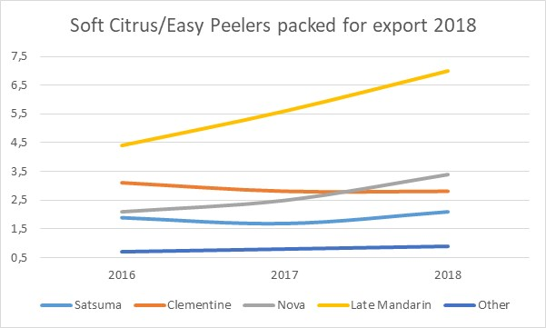
Late mandarins continue to dominate this category – rising to 7 million cartons in 2018. Nova’s are now number two (3.4 m), surpassing clementine’s (2.8 m). Satsuma’s remain fairly stable at 2.1 m cartons.

PACKED AND SHIPPED
To Week 44  Million 15 Kg Cartons | Packed | Packed | Packed | Shipped | Shipped | Original Estimate | Latest  Prediction | Final Packed
SOURCE: PPECB/Agrihub | 2016 | 2017 | 2018 | 2017 | 2018 | 2018 | 2018 | 2017
Grapefruit | 13.8 m | 15.7 m | 18.7 m | 15.4 m | 18.1 m | 16.8 m | 18.7 m | 15.7 m
Soft Citrus | 12.2 m | 13.4 m | 16.1 m | 13 m | 15.8 m | 14.7 m | 16.2 m | 13.4 m
Lemons | 15 m | 19 m | 19.8 m | 18.8 m | 19.3 m | 20.6 m | 19.9 m | 19 m
Navels | 26.2 m | 21.1 m | 26.6 m | 21.1 m | 26.3 m | 25.7 m | 26.6 m | 21.1 m
Valencia | 42 m | 53.8 m | 53.9 m | 52.9 m | 52 m | 53.9 m | 54.1 m | 53.8 m
Total | 109.2 m | 123 m | 135.1 m | 120.9 m | 131.4 m | 131.7 m | 135.5 m | 123 m

CGA GROUP OF COMPANIES (CRI, RIVER BIOSCIENCE, XSIT, CGA CULTIVAR COMPANY, CGA GROWER DEVELOPMENT COMPANY & CITRUS ACADEMY) ARE FUNDED BY SOUTHERN AFRICAN CITRUS GROWERS

