FROM THE DESK OF THE CEO (21/20)
(Follow me on Twitter justchad_cga)
Justin Chadwick 5 June 2020
“Do what you can, where you are, with what you have” Teddy Roosevelt
WORLD CITRUS ORGANISATION (WCO): SOUTHERN HEMISPHERE ESTIMATE FOR 2020
It is pleasing to see that most progressive industry associations have joined as country members of the WCO, as have a number of companies active in the citrus industry.
The WCO have released the southern hemisphere estimate for 2020. Analysis has been done on the export data.
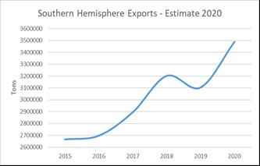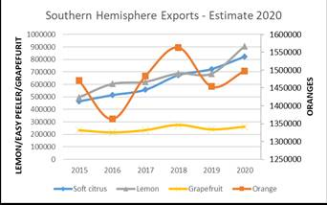
Since 2015, southern hemisphere export volumes have been on an upward trajectory, with a slight dip in 2019. The 2020 southern hemisphere estimate shows a resumption in that trajectory (12% increase). In these uncertain times, many will be watching the actual shipments to see how the sector performs. Lemon and easy peeler sectors are showing the most significant increases, not surprising given additional area planted to these varieties.
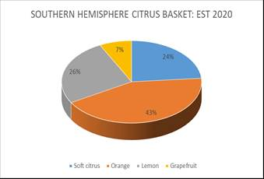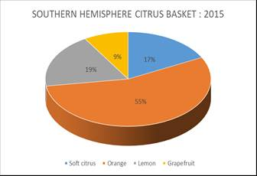
The southern hemisphere citrus basket has changed substantially from that of 2015.
PACKED AND SHIPPED
Million 15 Kg Cartons to end Week 22 | Packed | Packed | Packed | Shipped | Shipped | Original Estimate | Latest Prediction | Final Packed
SOURCE: PPECB/AgriHub | 2018 | 2019 | 2020 | 2019 | 2020 | 2020 | 2020 | 2019
Grapefruit | 9.8 m | 9.8 m | 9.5 m | 6.4 m | 6.9 m | 16.7 m | 14.6 m | 16.1 m
Soft Citrus | 5.6 m | 5.6 m | 7.4 m | 3.8 m | 4.9 m | 23.3 m | 22.7 m | 18.3 m
Lemons | 9.6 m | 9.3 m | 15.1 m | 6.4 m | 11.4 m | 26.4 m | 27.6 m | 22.1 m
Navels | 6.3 m | 5.2 m | 6.5 m | 1.8 m | 2.6 m | 26.5 m | 26.5 m | 24.3 m
Valencia | 0.3 m | 0.4 m | 0.5 m | - | 0.1 m | 50.4 m | 50.5 m | 46.8 m
Total | 31.6 m | 30.3 m | 39 m | 18.4 m | 25.9 m | 143.3 m | 141.9 m | 127.5 m

