FROM THE DESK OF THE CEO (31/20)
(Follow me on Twitter justchad_cga)
Justin Chadwick 31 July 2020
“Ultimately, the only wealth that can sustain any community, economy or nation is derived from the photosynthetic process - green plants growing on regenerating soil.” Allan Savory
CONFRONTING CLIMATE CHANGE
CGA was a founding member of the Confronting Climate Change (CCC) project - a South African fruit and wine initiative that began in 2008. The basic concept for the project was to enable producers and supply chain stakeholders to identify risks and opportunities relating to carbon emissions. This is achieved through a benchmarking process whereby data is captured into an online Carbon Calculator and participants can observe how their figures compare to others around them. The tool quickly picks up “hotspots” in farming operations which are, not surprisingly, often linked to energy intensive activities. In this sense the CCC team are able to guide users towards more efficient – and cost saving – alternative solutions. Besides illustrating how reducing electricity consumption over time resulted in reductions in CO₂ emissions, the charts highlight CCC participation across the country. Although the total citrus area on the records is pleasing (+17 400 ha), clearly more involvement form the northern growing regions is needed!
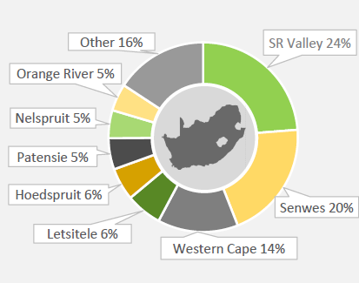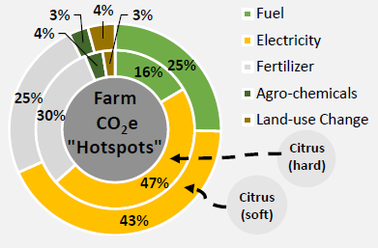
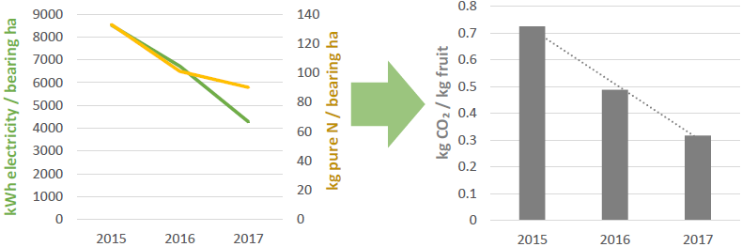
These charts were extracted from the latest Citrus Benchmarking report compiled by the CCC team – copies of which are available from CGA (ph@cga.co.za). Also visit the CCC website for more information: https://www.climatefruitandwine.co.za/
HARVEST SA highlights the CGA co-chairing of the World Citrus Organisation in their July/August Issue – link below:
https://indd.adobe.com/view/e2eea210-13f6-467e-a5e9-45f115215044
PACKED AND SHIPPED
The Valencia Focus Group have updated and lowered their projected export volumes to 47.9 m cartons
Million 15 Kg Cartons to end Week 30 | Packed | Packed | Packed | Shipped | Shipped | Original Estimate | Latest Prediction | Final Packed
SOURCE: PPECB/AgriHub | 2018 | 2019 | 2020 | 2019 | 2020 | 2020 | 2020 | 2019
Grapefruit | 18.3 m | 16 m | 14.3 m | 13.3 m | 13.1 m | 16.7 m | 15.1 m | 16.1 m
Soft Citrus | 12.1 m | 13.4 m | 17.5 m | 10.8 m | 14.5 m | 23.3 m | 22.8 m | 18.3 m
Lemons | 16.4 m | 18.5 m | 24.3 m | 14 m | 19.7 m | 26.4 m | 26.7 m | 22.1 m
Navels | 22.6 m | 19.3 m | 21.4 m | 15 m | 17.6 m | 26.5 m | 26.4 m | 24.3 m
Valencia | 15.3 m | 15 m | 19.7 m | 9.2 m | 11.7 m | 50.4 m | 47.9 m | 46.8 m
Total | 84.7 m | 82.2 m | 97.2 m | 62.3 m | 76.6 m | 143.3 m | 138.9 m | 127.5 m

