FROM THE DESK OF THE CEO (43/18)
(Follow me on Twitter justchad_cga)

Justin Chadwick 26 October 2018
“Agriculture is the most healthful, most useful and most noble employment of man” George Washington
With just 100 000 cartons of the estimated 19.9 million 15Kg cartons of lemons still to pack, the final volume should fall just 3% below the March estimate – well done Lemon Focus Group. The 2018 lemon crop packed for export will be a record – just shy of 1 million cartons more than the 2017 volume.
Not only was the total almost on estimate – so were many of the regional estimates. The biggest region (Sundays River) at 8.65 million cartons was 1.7% over budget; Senwes at 4.13 m cartons was 8% under estimate; while Boland at 1.2 m cartons is 4% under estimate.
2018 LEMON SEASONAL REVIEW

There were some shifts in export destinations of southern African lemons in regional terms. The Middle East decreased in both absolute terms (7.5 m cartons in 2017 to 6.7 m in 2018) and percentage terms (40% to 35%). This was also the case in South East Asia where volumes decreased from 3 m (2017) to 2.3 m (2018). Europe picked up some of this fruit (from 3.8 m to 5.6m, from 20% in 2017 to 29% in 2018); as did the UK – 1.4 m (7%) to 1.7 m (9%). Russia also experienced a slight drop – from 2 m (11%) in 2017 to 1.8 m (9%) in 2018; while North America increased from 0.8 m to 0.9 m (4 to 5%). With respect to individual countries Netherlands (3.2 million 15
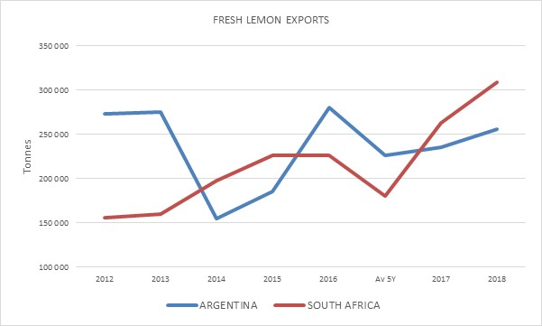
Kg cartons) has surpassed UAE (3 m). Saudi Arabia (1.9 m) is just ahead of Russia (1.8 m), with UK (1.6 m) rounding out the top five.
Most sources list limes and lemons together. With respect to export volumes, it is safe to assume that Mexico is predominantly limes, leaving Spain as number one global lemon exporter (0.55 m tonnes). Turkey (0.45 m tonnes) follows at number two, while South Africa and Argentina alternate at three and four (between 0.25 and 0.3 million tonnes).
DAFF CITRUS COORDINATING MEETING
Congratulations to Ernest Phoku and his team from DAFF – professional and thorough presentations as the citrus industry embraces a true public-private partnership. These coordinating meetings started many years back – and initially the challenge was to get industry to attend. The challenge now is to get the industry to RSVP – the 90 that did send confirmation of attending was far short of the over 240 who filled the hall at Loskop Forever resort. A great turnout from industry – with all elements of the value chain in attendance. For those who could not attend DAFF will now take this information on a roadshow; please RSVP (asseblief) so that we can ensure the venues can accommodate you. 29/10 at 09h00 at Musina Agricultural Hall, Showgrounds; 30/10 Tzaneen Country Lodge 09h00; 31/10 Hoedspruit Hengel Klub 10h00; 1/11 Nelspruit CRI Board room 09h00; 5/11 KZN FPT Training room 09h00; 6/10 Africanos Sundays River at 09h00 and 8/11 Stellenbosch ARC Nietvoorbij at 09h00.
PACKED AND SHIPPED
To Week 42  Million 15 Kg Cartons | Packed | Packed | Packed | Shipped | Shipped | Original Estimate | Latest  Prediction | Final Packed
SOURCE: PPECB/Agrihub | 2016 | 2017 | 2018 | 2017 | 2018 | 2018 | 2018 | 2017
Grapefruit | 13.8 m | 15.7 m | 18.7 m | 15.4 m | 18.1 m | 16.8 m | 18.7 m | 15.7 m
Soft Citrus | 12.2 m | 13.4 m | 16.1 m | 13 m | 15.8 m | 14.7 m | 16.2 m | 13.4 m
Lemons | 15 m | 19 m | 19.8 m | 18.8 m | 19.3 m | 20.6 m | 19.9 m | 19 m
Navels | 26.2 m | 21.1 m | 26.6 m | 21.2 m | 26.3 m | 25.7 m | 26.6 m | 21.1 m
Valencia | 42 m | 53.7 m | 53.8 m | 50.4 m | 48.4 m | 53.9 m | 54.1 m | 53.8 m
Total | 109.2 m | 122.9 m | 135 m | 118.8 m | 127.9 m | 131.7 m | 135.5 m | 123 m

CGA GROUP OF COMPANIES (CRI, RIVER BIOSCIENCE, XSIT, CGA CULTIVAR COMPANY, CGA GROWER DEVELOPMENT COMPANY & CITRUS ACADEMY) ARE FUNDED BY SOUTHERN AFRICAN CITRUS GROWERS

