FROM THE DESK OF THE CEO (25/18)
(Follow me on Twitter justchad_cga)
Justin Chadwick 22 June 2018
“To deny people their human rights is to challenge their very humanity” Nelson Mandela

DAM LEVELS IN CITRUS GROWING REGIONS OF SOUTH AFRICA
Those living in the Western Cape have been celebrating good rains that heralded a return to normal for the winter rainfall region. Dams in that region are now above similar levels last year – although many will say that they are not out of the woods, the rains are a welcome relief.
Spare a thought for those a bit further up the coast in the Eastern Cape – the Patensie/Gamtoos region is facing dire conditions as the Kouga dam stands at 7.6 % (last year 18.5%) – please keep them in your thoughts and prayers.
The rest of the Eastern Cape dams are at good levels, as is the Gariep dam that feeds the Sundays River region.
Dams in the north (Mpumalanga and Limpopo) are also in a better shape that 2017 – ensuring enough water to see out 2018 and set a good crop for 2019.
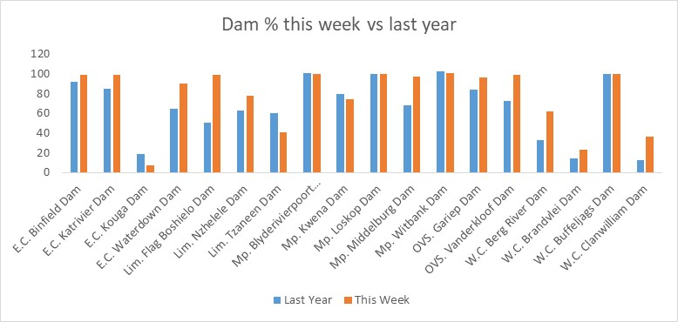

PACKED AND SHIPPED
As grapefruit starts to colour up so has the rate of packing stepped up. The Grapefruit Focus Group met this past week and increased their prediction – now a million cartons over the original estimate. Soft citrus packing is also ahead of 2017, and the Soft Citrus Focus Group have made another upward adjustment to the prediction. The labour issues in the Eastern Cape affected lemon and navel picking and packing, with lemon packing lagging 2017. Valencia’s are also off to a slow start.
To Week 24  Million 15 Kg Cartons | Packed | Packed | Packed | Shipped | Shipped | Original Estimate | Latest  Prediction | Final Packed
SOURCE: PPECB | 2016 | 2017 | 2018 | 2017 | 2018 | 2018 | 2018 | 2017
Grapefruit | 10 m | 11.7 m | 13.3 m | 9.2 m | 9.2 m | 16.8 m | 17.8 m | 15.7 m
Soft Citrus | 7 m | 6.8 m | 7.4 m | 5.7 m | 5.8 m | 14.7 m | 16.4 m | 13.4 m
Lemons | 9.2 m | 11.9 m | 10.9 m | 10.1 m | 9.8 m | 20.6 m | 20.3 m | 19 m
Navels | 13.5 m | 10.5 m | 11.3 m | 7.5 m | 6.9 m | 25.7 m | 25.3 m | 21.1 m
Valencia | 1.6 m | 2.8 m | 0.9 m | 1.1 m | 0.3 m | 53.9 m | 53.2 m | 53.8 m
Total | 41.3 m | 43.7 m | 43.8 m | 33.6 m | 32 m | 131.7 m | 133 m | 123 m

CGA GROUP OF COMPANIES (CRI, RIVER BIOSCIENCE, XSIT, CGA CULTIVAR COMPANY, CGA GROWER DEVELOPMENT COMPANY & CITRUS ACADEMY) ARE FUNDED BY SOUTHERN AFRICAN CITRUS GROWERS

