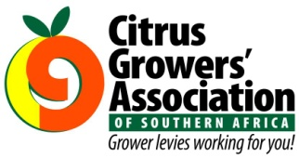
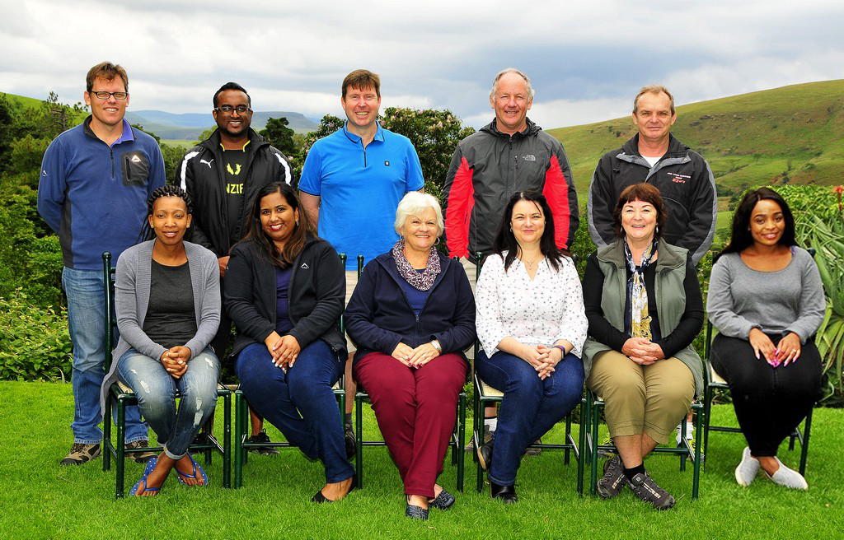
WISHES FOR A MERRY CHRISTMAS AND A HAPPY NEW YEAR FROM THE CGA STAFF

Absent from photo: Mitchell Brooke, Deon Joubert, Faisal Asmal and Rauff Dawood.
FROM THE DESK OF THE CEO (49/17)
(Follow me on Twitter justchad_cga)
Justin Chadwick 22 December 2017
As 2017 comes to a close I would like to wish all those associated with the southern African citrus industry a Blessed Christmas. On behalf of all staff at the CGA Group we value the support received and will continuously endeavour to ensure that the industry goes from strength to strength. It is a privilege to work with, and for, such a progressive group of growers – we do not take our position as industry representatives lightly and will strive to do our work with integrity, fairness and enthusiasm.
To our partners in Government and in the value chain – thank you for your support and commitment to ensuring a competitive, sustainable and transformed industry.

THE CGA GROUP OF COMPANIES (CRI, RIVER BIOSCIENCE, XSIT, CGA CULTIVAR COMPANY, CGA GROWER DEVELOPMENT COMPANY AND CITRUS ACADEMY) ARE FUNDED BY SOUTHERN AFRICAN CITRUS GROWERS

