FROM THE DESK OF THE CEO (44/18)
(Follow me on Twitter justchad_cga; just got follower number 1 000!!))

Justin Chadwick 2 November 2018
“If Twitter, Youtube, and Google were part of my school subjects, my parents would be so proud of me” Anon

2018 NAVEL SEASONAL REVIEW
Keeping the trend going navel oranges also experienced a record export volume – at 26.6 million cartons just ahead of 2016 (26.2 m).
This was just 4% over the March estimate. Before congratulating the Navel Focus Group, it is worth noting that there were big regional swings – Senwes remains the biggest region with 8.8 m cartons – a huge 34% over estimate, while Sundays River slipped to third largest region recording a 5.1 m carton export volume, 15% lower than estimate. It is Western Cape that took over second spot – their 6.1 m cartons almost spot on estimate. Patensie was 11% under estimate (3 m vs 3.4 m), while Nelspruit was 3% under estimate (1.6 m vs 1.7m).
In terms of regional distribution, a decrease in Europe (from 30% in 2017 to 26% in 2018) was taken up by Middle East (23% to 26%). Distribution to other regions did not differ materially from 2017– South East Asia 18%, North America 15%, Russia and UK both 5% and Asia 3%.
As with grapefruit and lemons, Netherlands remained the number one importer at 4.2 million cartons. They were followed by Saudi Arabia (2.9 m), UAE (2.5 m) and USA (2.4 m). Making an appearance from nowhere at number five was China – rising from 0.8 m cartons in 2017 to 2 million cartons in 2018.
SOUTHERN AFRICAN CITRUS EXPORTS HIT 2 MILLION TONS
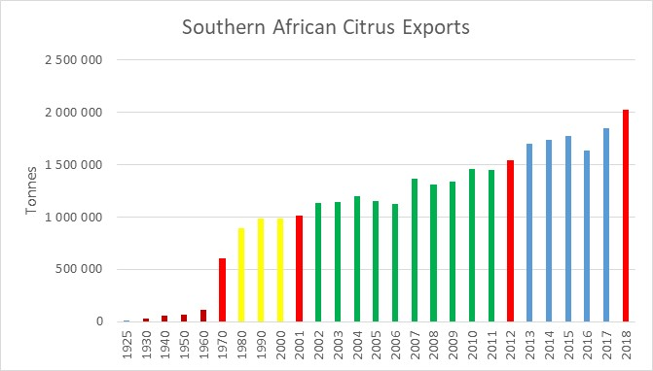
I can remember the citrus industry hitting 1 million tonnes of exports like it was yesterday – I was a member of a panel at a Southern Hemisphere Fruit Conference, and Chris White asked me whether this was a reason to celebrate or not. The answer was that it was both cause for celebration and concern; a growing industry was a good thing from a production perspective, but if we failed to grow market demand at the same pace, problems would arise.
The industry has now hit 2 million tonnes, and the same sentiments exist.
The pace of growth is speeding up; whereas it took the first 60 years to reach 500 000 tonnes, the next step to 1 million tonnes took 31 years, and from 1 m to 1.5 took 12 years; the last 500 000 tonne increase taking just 6 years (and forecasts show the next 500 000 tonnes will take 3 years).
CITRUS SHORT COURSE
The Citrus Academy has added another Citrus Short Course workshop, taking place on 25-26 February 2019 at the Hoedspruit Hub. Please visit the Citrus Academy website to register and for more information: www.citrusacademy.org.za
PACKED AND SHIPPED
To Week 43  Million 15 Kg Cartons | Packed | Packed | Packed | Shipped | Shipped | Original Estimate | Latest  Prediction | Final Packed
SOURCE: PPECB/Agrihub | 2016 | 2017 | 2018 | 2017 | 2018 | 2018 | 2018 | 2017
Grapefruit | 13.8 m | 15.7 m | 18.7 m | 15.4 m | 18.1 m | 16.8 m | 18.7 m | 15.7 m
Soft Citrus | 12.2 m | 13.4 m | 16.1 m | 13 m | 15.8 m | 14.7 m | 16.2 m | 13.4 m
Lemons | 15 m | 19 m | 19.8 m | 18.8 m | 19.3 m | 20.6 m | 19.9 m | 19 m
Navels | 26.2 m | 21.1 m | 26.6 m | 21.2 m | 26.3 m | 25.7 m | 26.6 m | 21.1 m
Valencia | 42 m | 53.8 m | 53.9 m | 52.6 m | 51.8 m | 53.9 m | 54.1 m | 53.8 m
Total | 109.2 m | 123 m | 135.1 m | 121 m | 131.3 m | 131.7 m | 135.5 m | 123 m

CGA GROUP OF COMPANIES (CRI, RIVER BIOSCIENCE, XSIT, CGA CULTIVAR COMPANY, CGA GROWER DEVELOPMENT COMPANY & CITRUS ACADEMY) ARE FUNDED BY SOUTHERN AFRICAN CITRUS GROWERS

