FROM THE DESK OF THE CEO (42/18)
(Follow me on Twitter justchad_cga)

Justin Chadwick 19 October 2018
“There is no trade-off between social inclusion and a country’s level of competitiveness” Saadi Zahidi, WEF

2018 GRAPEFRUIT SEASONAL REVIEW
The curtain is down on the 2018 grapefruit season and it has been a record in terms of volume packed for export. The 16.4 million 17 Kg cartons packed (279 000 tonnes) surpasses the 2013 volume of 16.1 million cartons.
Estimating the 2018 grapefruit crop proved to be challenging for many of the Grapefruit Focus Group members. The initial estimate was for 14.845 million cartons – the final tally being almost 11% over the estimate. Within these estimates, some VFG members were way out (Limpopo River packed 29% more
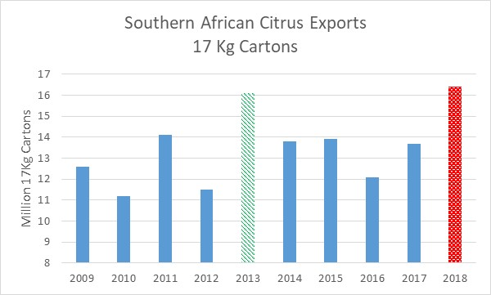 than estimate, Letsitele 26%). Others were within the acceptable 10% difference – Onderberg 8% over while Oranje Rivier was 6% less than estimated. Nkwalini was 31% less than estimated.
Although the final results in terms of earnings from grapefruit exports will only be known in the new year, anecdotal evidence indicates a difficult marketing year.
Netherlands remains the global leader in terms of importation of southern African grapefruit – importing some 70 000 tonnes (2017 63 000 tonnes). The big news in the grapefruit world is the rise in exports to China – from 20 000 tonnes in 2017, to 51 000 tonnes in 2018. This catapults China into number two position in terms of southern African grapefruit exports, with Japan now falling into third spot at 35 000 tonnes. Russia (17 000 tonnes) and UK (11 000 tonnes) round out the top five. Interestingly, grapefruit exports to Hong Kong also increased – from 6 000 tons to 9 000 tons.
With this record crop, South Africa remains the number one exporter of grapefruit globally. In the southern hemisphere, other citrus producing countries have all but stopped exporting grapefruit, leaving southern Africa as the sole exporter of any significant volume.
CGA CITRUS SUMMIT 2019
The organizing committee are hard at work to deliver an excellent CGA Citrus Summit in Port Elizabeth from 12-14 March 2019. It’s never too early to register – so please visit www.cga.co.za and follow the links to registration. We have already confirmed some excellent speakers, which will be profiled in forthcoming newsletters, and available on the website. CRI are assisting in putting together two options for the pre-Summit tours – one to Patensie and one to Sundays River. The Summit will kick off with a Welcome Function on Tuesday evening (12 March 2019), and finish with a lunch on Thursday 14 March. We are delighted that Standard Bank have continued their support of the Summit as the headline sponsor. If you have any questions regarding the Summit please do not hesitate to contact me (justchad@iafrica.com) or Gloria (gloria@cga.co.za).
I plan to attend next year – and will stay off the bike in the lead up to the Summit.

PACKED AND SHIPPED

To Week 41  Million 15 Kg Cartons | Packed | Packed | Packed | Shipped | Shipped | Original Estimate | Latest  Prediction | Final Packed
SOURCE: PPECB/Agrihub | 2016 | 2017 | 2018 | 2017 | 2018 | 2018 | 2018 | 2017
Grapefruit | 13.8 m | 15.7 m | 18.7 m | 14.9 m | 18.1 m | 16.8 m | 18.7 m | 15.7 m
Soft Citrus | 12.2 m | 13.4 m | 16.1 m | 13 m | 15.8 m | 14.7 m | 16.5 m | 13.4 m
Lemons | 15 m | 19 m | 19.6 m | 18.8 m | 19.2 m | 20.6 m | 19.9 m | 19 m
Navels | 26.2 m | 21.1 m | 26.6 m | 21.1 m | 26.3 m | 25.7 m | 26.6 m | 21.1 m
Valencia | 42 m | 53.5 m | 52.4 m | 50.3 m | 47.6 m | 53.9 m | 53.5 m | 53.8 m
Total | 109.2 m | 122.7 m | 133.4 m | 117.8 m | 127 m | 131.7 m | 135.2 m | 123 m

CGA GROUP OF COMPANIES (CRI, RIVER BIOSCIENCE, XSIT, CGA CULTIVAR COMPANY, CGA GROWER DEVELOPMENT COMPANY & CITRUS ACADEMY) ARE FUNDED BY SOUTHERN AFRICAN CITRUS GROWERS

