FROM THE DESK OF THE CEO (14/21)
(Follow me on Twitter justchad_cga)
Justin Chadwick 16 April 2021
“Those who wish to sing always find a song.” — Swedish Proverb
AGRI’S GOT TALENT
Calling on all citrus growers and packhouse managers to encourage their talented agricultural workforce to enter Agri's Got Talent 2021! A joint venture between Hortgro, the Citrus Growers’ Association, Vinpro, SATI (South African Table Grape Industry) and the Western Cape Department of Agriculture, Agri's Got Talent is more than just a singing competition, it is also a social development programme for agricultural workers in the fruit and wine industries.
2021 will be the eighth year that the competition has been held and contestants can enter by sending voice recordings or videos via WhatsApp to 082 372 1577 or email to agrisgottalent@gmail.com, including the following details:
- Name & surname
- Date of birth
- Own cell phone number
- Name of farm / cellar / pack house
- Job description
- How long you have been working on the farm, in the pack house or cellar
- Nearest town
- Supervisor name and cell phone number
Entries close 17 July 2021.
For more information and promotion material please contact Desiree Schonken desiree@citrusacademy.org.za
WEEKLY STATISTIC: 2021 LEMON ESTIMATE
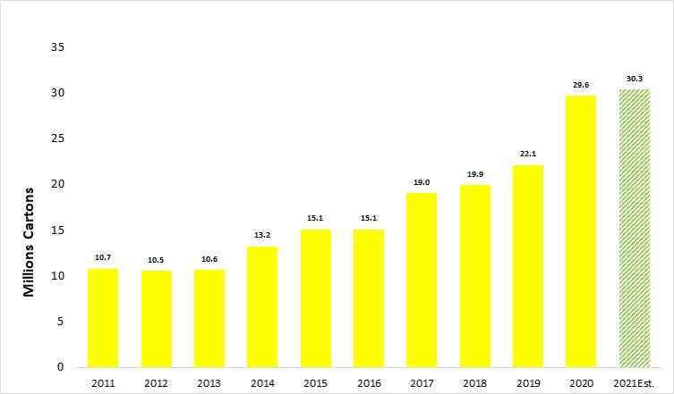
After a significant increase in lemons exported between 2019 and 2020, the estimated export volume for 2021 from the Lemon Focus Group is at a similar level to that achieved in 2020.
PACKED AND SHIPPED
Up to the end of week 14 almost 60% of the satsuma crop is already packed. Lemon packing in 2021 is mirroring that of 2020 with almost five million cartons packed to date. Grapefruit packing is ahead of 2020. The Variety Focus Groups will meet in April and review the predicted export volumes for 2021.
To Week 15  Million 15 Kg Cartons | Packed | Packed | Packed | Shipped | Shipped | Original Estimate | Latest  Prediction | Final Packed
SOURCE: PPECB/AgriHUB | 2019 | 2020 | 2021 | 2020 | 2021 | 2021 | 2021 | 2020
Grapefruit | 0.4 m | 0.5 m | 1.1 m | 0.1 m | 0.1 m | 18 m | 18 m | 15.5 m
Soft Citrus | 0.7 m | 1.3 m | 1.1 m | 0.2 m | 0.3 m | 30.5 m | 30.5 m | 23.6 m
Lemons | 2.1 m | 5 m | 4.9 m | 3 m | 2.8 m | 30.2 m | 30.2 m | 29.6 m
Navels | 0.1 m | 0.1 m | 0.1 m | - | - | 26.3 m | 26.3 m | 26.2 m
Valencia | 0.2 m | - | - | - | - | 58 m | 58 m | 55.1 m
Total | 3.5 m | 6.9 m | 6.8 m | 3.3 m | 3.2 m | 163 m | 163 m | 150 m

