FROM THE DESK OF THE CEO (43/17)
(Follow me on Twitter justchad_cga)
Justin Chadwick 10 November 2017
“No man has a good enough memory to be a successful liar” Abraham Lincoln

CITRUS BLACK SPOT: RIVER BIOSCIENCE PROVIDES A NEW PRODUCT TO COMBAT THE FUNGUS
Citrus black spot (CBS), caused by the fungus Guignardia citricarpa, is important as a fruit disease and all commercial cultivars are susceptible. The disease is severe and found mostly in hot, humid, low-lying tropical regions. It can however occur sporadically in lower summer rainfall regions such as the Eastern Cape.
Regulation EC/422/2014, which is applicable to South African citrus entering the European Union (EU), requires 100 percent control of CBS on export fruit to the EU.
Commercially acceptable levels of control of CBS can only be achieved through the use of plant protection products. Citrus fruit is susceptible to infection from the point of fruit set until natural resistance against the disease develops in the rind by the end of January while some types, like lemons, are still susceptible until the end of March. As a result of the extended period fruit is vulnerable to CBS, growers rely on a 4 – 5 month long spray programme to protect their crops.
There are currently very few active ingredients registered for CBS control on the market and repeated applications of the same products can result in the development of resistance. Most of these products are also detrimental to beneficial insects, which results in secondary pest outbreaks leading to further use of synthetic chemistry. This pesticide treadmill makes farming with Integrated Pest Management principles and practises almost impossible. River Bioscience is proud to announce the registration of a new CBS control product: RB1TM.
RB1 TM is a systemic and contact fungicide with the active ingredient being Dipotassium phosphate. There are no other products with this active ingredient for CBS on the market and this offers growers a key alternative to be included in their CBS spray programmes to reduce the chance of resistance occurring.
Another key attribute of RB1 TM is that it is IPM compatible. Unlike other products on the market, RB1 TM can be considered a “soft” product, which allows growers to once again use beneficial insects for the control of other key pests.
RB1 TM is yet another demonstration of the CGA group benefitting its growers by conceptualising new possibilities in the research arm, CRI, and River Bioscience (Pty) Ltd following through with successful commercialisation of this promising innovation to benefit the citrus industry as a whole. For advice and assistance on how to add this to a spray programme or to obtain RB1 TM please contact the agent in your area or River Bioscience directly.
Clint Lawson | clint@riverbio.com | +(27) 83 676 9784; Chris Hendriks | chris@riverbio.com | +(27) 79 858 3233
BLEAK OUTLOOK FOR THE PRICE OF DIESEL
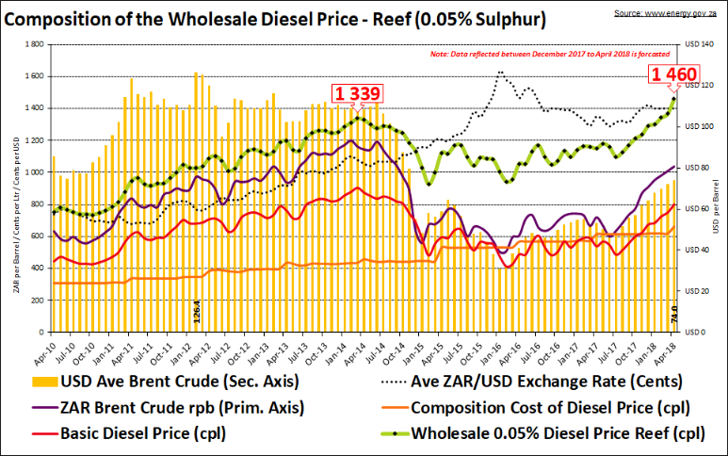
Oil speculators and traders are warning that the oil price could increase upwards to between USD75-USD100 per barrel by March 2018. Given that the Rand is trading negatively against the US Dollar (~R14/USD) this could have dire consequences on the cost of fuel in South Africa in the coming months; if the price of oil continues to rise (currently ~USD62 per barrel up from USD31 in January 16). Since 2009, the fuel tax and accident fund levies have increased by R2.64 per litre and it is expected that this could increase further in April 2018 given the current fiscal pressures. The wholesale price of Diesel (0.05% Sulphur) is currently R12.36 per litre and considering the forecast it is likely to increase to between R14.50-R15.00 per litre by April 2018. This means the pump price could reach as high as R16.00 per litre; this would be a negative factor for transport costs during the 2018 season.
PACKED AND SHIPPED
To End Week 44  Million 15 Kg Cartons | Packed | Packed | Packed | Shipped | Shipped | Original Estimate | Latest  Prediction | Final Packed
SOURCE: PPECB/AGRIHUB | 2015 | 2016 | 2017 | 2016 | 2017 | 2017 | 2017 | 2016
Grapefruit | 16.1 m | 13.8 m | 15.7 m | 13.2 m | 15.4 m | 15.6 m | 15.7 m | 13.8 m
Soft Citrus | 10 m | 12.2 m | 13.4 m | 11.3 m | 13 m | 13.2 m | 13.4 m | 12.2 m
Lemons | 15 m | 15 m | 19 m | 14.6 m | 18.8 m | 17.5 m | 19 m | 15 m
Navels | 24.5 m | 26.2 m | 21.1 m | 25.5 m | 21.1 m | 26.3 m | 21.1 m | 26.2 m
Valencia | 52.5 m | 41.8 m | 53.8 m | 39.8 m | 50.8 m | 50.1 m | 53.8 m | 41.8 m
Total | 118.1 m | 109 m | 123 m | 104.4 m | 118.9 m | 122.7 m | 123 m | 109 m
THE CGA GROUP OF COMPANIES (CRI, RIVER BIOSCIENCE, XSIT, CGA CULTIVAR COMPANY, CGA GROWER DEVELOPMENT COMPANY & CITRUS ACADEMY) ARE FUNDED BY SOUTHERN AFRICAN CITRUS GROWERS

