FROM THE DESK OF THE CEO (16/20)
(Follow me on Twitter justchad_cga)
Justin Chadwick 1 May 2020
“An empty stomach is not a good political advisor” Albert Einstein
CGA STATISTICS BOOK: RETURNS 2019
Last week’s newsletter showed extracts from the CGA Statistics Booklet covering export value trends for the four citrus sectors. This week we look at overall citrus earnings (the black line shows total industry earnings which dipped down slightly to just below R20 billion. The bars show tons of citrus fruit exported, processed and sold on the local market. Local market volumes remain at low levels. The processed volumes increased slightly in 2019 with a concommitant decrease in export volumes (dipped below 2018 levels, second highest export volume in past ten years). Book available from johne@cga.co.za
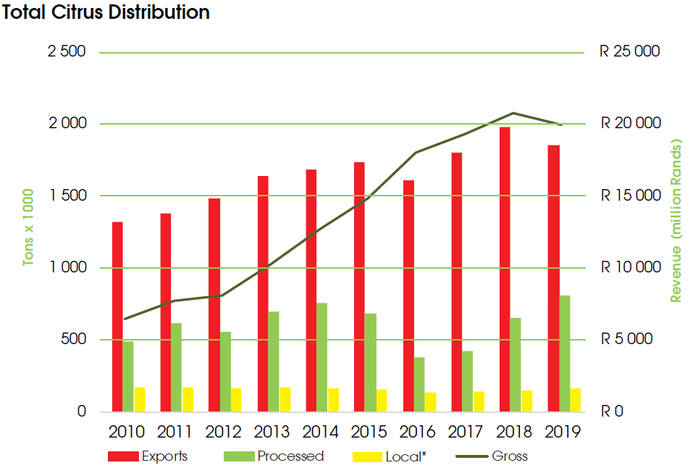
TRANSPORT FORUM COMES TO YOUR OFFICE/HOME
Transport Forum SIG will be hosting a live online event on 7 May titled "Port Operations in 2020". This should be of particular interest to all stakeholders that are involved in exporting of citrus as it will provide an overview of what developments are in the pipeline at the various ports (in particular the container terminals). The event also always for stakeholders to post questions to the panellists if there are any matters that you would like to address. Register on the following link: https://www.transportsig.com/74-next-sig-meeting/933-transport-forum-sig-7-may-2020

