RESEARCH FACILITIES RETURN TO THE INDUSTRY
In an exciting and somewhat emotional ceremony on Wednesday evening, 26th September, Capespan handed over the keys of the Nelspruit research facility and Uitenhage foundation block to the Citrus Growers Association. CGA would like to thank Capespan for enabling the CGA to take ownership of these important industry assets, and to Tonie Fuchs, Angelo Peterson, Dawie Ferreira and Rowan Vickery for travelling from the “Republic” of the Western Cape to partake in the occasion. In the 1970’s the Solomon family donated the land on which the present Nelspruit facility stands and it was fitting that Marc Solomon represented the Solomon family and shared some historical perspective of those early days. Piet Smit (CRI Chairman) opened proceedings, with Justin Chadwick, CGA CEO receiving the purchase and sale agreement from Tonie Fuchs. Tim Grout and Paul Fourie gave some interesting information on the workings of the Nelspruit and Uitenhage facilities respectively and Vaughan expressed the importance of a permanent home for the CRI staff. Finally, Ben Vorster unveiled a plaque commemorating the occasion.

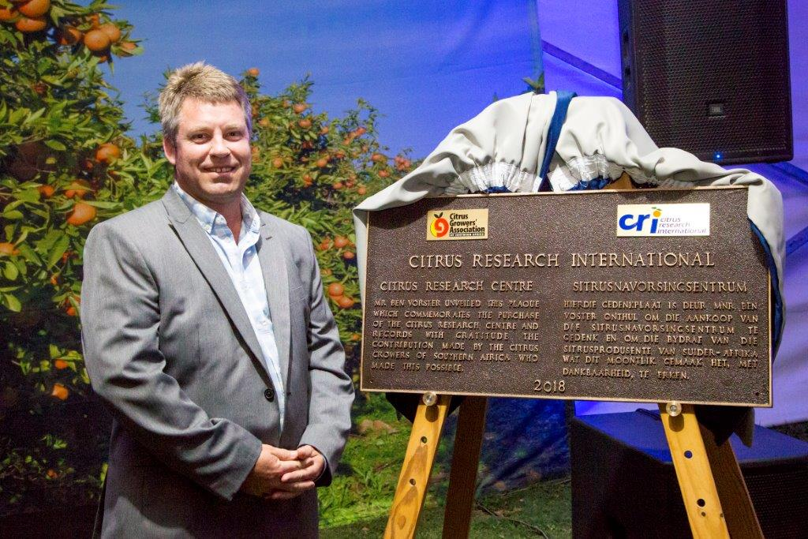
Ben Vorster, CGA Chairman, unveils the Plaque. 26th September 2018
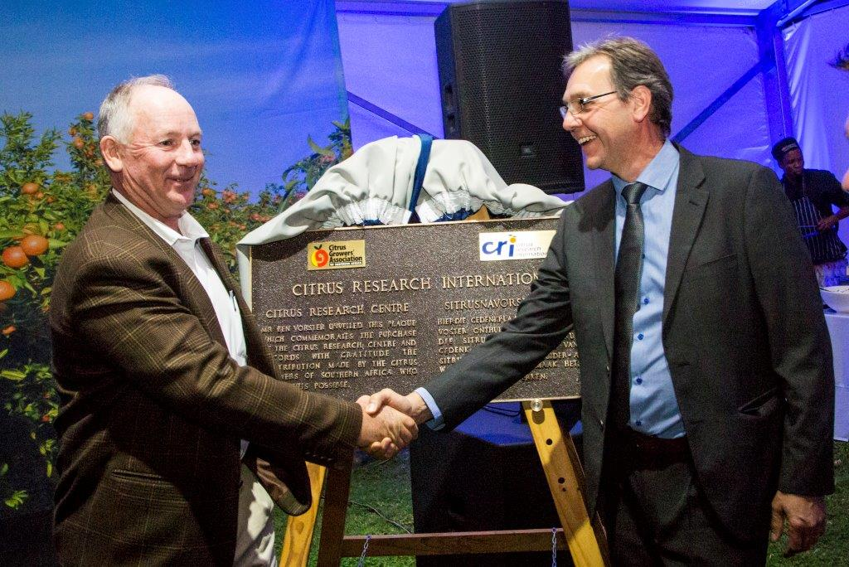
Justin Chadwick, CGA CEO and Vaughan Hattingh, CRI CEO are thrilled
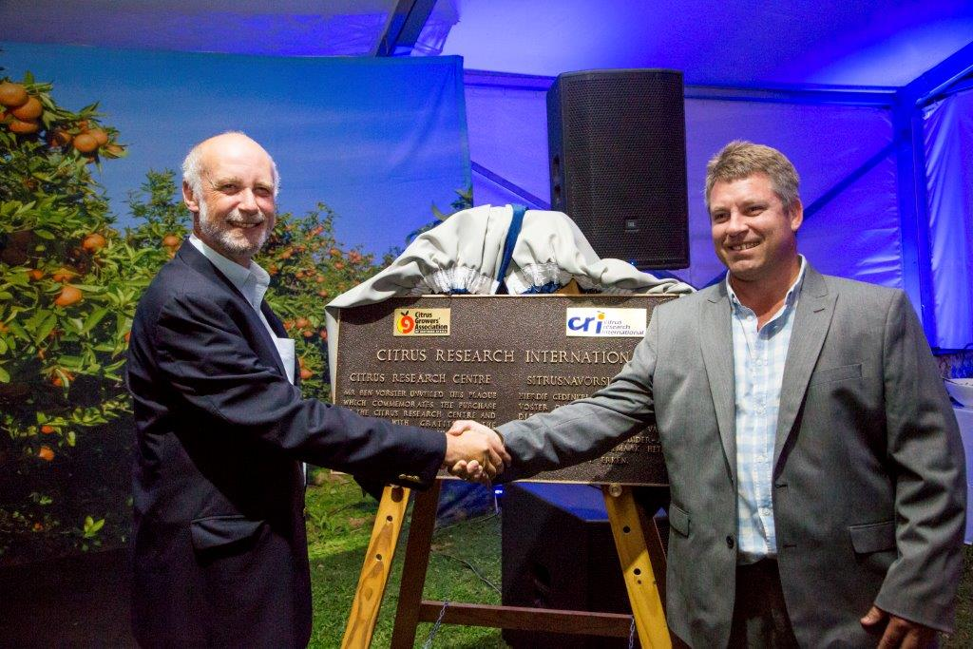
Marc Solomon and Ben Vorster.

