# Port challenges are bearing bad fruit

[NEWS](https://www.iol.co.za/mercury/news) / 5 NOVEMBER 2019, 09:00AM / **JUSTIN CHADWICK**

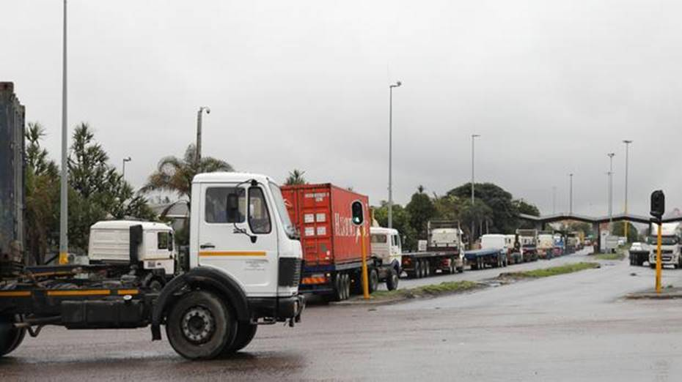Share on Facebook

The Durban Container Terminal, for example, has experienced a 78% increase in truck turnaround time resulting in severe delays in offloading trucks. There are not enough vessel gangs at the Durban, Ngqura and Cape Town terminals to handle the number of vessels. Picture: Doctor Ngcobo/African News Agency(ANA)

Durban - After the Medium-Term Budget Speech by Minister of Finance Tito Mboweni and the latest Quarterly Labour Force Survey, there is much debate about how best to grow the economy and create jobs.

The national government has emphasised the role that infrastructure plays in economic development over the past few weeks, something of which I have first-hand experience in the citrus industry.

Readily accessible ports with good-capacity container terminals have allowed our industry to attain the number 2 spot in the global citrus export chart, bringing R20billion into the country, uplifting rural communities and supporting 120000 jobs.

Unfortunately, all of this success is now at risk, due to a serious decline in the productivity of the container terminals that provide us access to the world’s markets.

The much publicised “go-slow” strike action in June/July this year resulted in unprecedented delays and nearly shut down export through the Ngqura Container Terminal as ships were turned away without unloading.

But the source of the problem goes further than strikes - even with everyone at work, operational staff and training backlogs mean that there are not enough capable workers available to operate the terminals effectively.

The Durban Container Terminal, for example, has experienced a 78% increase in truck turnaround time resulting in severe delays in offloading trucks. There are not enough vessel gangs at the Durban, Ngqura and Cape Town terminals to handle the number of vessels.

Maintenance and replacement of equipment is also a serious problem. The skeleton staff are operating aged and decrepit cranes and landside equipment - which is not only slow and continually interrupted by breakdowns, but dangerous. Growth in exports is all very well, but if we don’t invest in the infrastructure to handle the increased traffic, it won’t be sustainable.

Underlying all of this is the spectre of state capture. Recent evidence before the Zondo commission outlined how individuals were strategically placed in certain positions to gain access to juicy tenders, including those critical to maintaining efficient container terminal operations.

Instead of being spent on essential equipment, maintenance and staff, funds disappeared into the pockets of leaders unconcerned with the future of South African industries. It’s hardly surprising that nearly every aspect of operations has slowed to a crawl.

For those of us in the fruit exporting industry, delays have grave consequences.

Perishable goods must be exported to reach their markets on time in the freshest condition - if they don’t, millions of rand in produce can be lost.

In addition, the markets these goods are destined for are fiercely competitive. If we develop a reputation as an unreliable exporter, there are many other countries that will be quick to take our place in the market.

Once that reputation is cemented, it’s incredibly hard to break free of.

South Africa’s reputation is taking a beating in so many areas at the moment. We can’t afford to be seen as an unreliable exporter, or as a country not worth investing in due to poor infrastructure.

There are plenty of ports in neighbouring countries that SADC regional exporters might choose to go through instead, such as Walvis Bay, Luderitz, Maputo, Beira, Nacala, and Dar es Salaam - all of which are ploughing major investments into port and terminal developments.

Even for South African producers, for whom this is a less efficient option for export, it may prove more reliable than our ports at home.

Moreover, if yet another state-owned-enterprise rots from the core, investor confidence in our country as a whole is unlikely to recover.

Transnet was previously a solid contributor to the government revenue, and now finds itself downgraded by Moody’s and carrying R42bn in irregular and wasteful expenditure.

Luckily, the national government has recognised the urgency of the situation.

We are working closely with Minister of Public Enterprises, Pravin Gordhan, acting Transnet chief executive Michelle Phillips and her team to resolve the problems that are plaguing exporters.

There’s a good reason for this - if our terminals are efficient enough to grow citrus exports by 25%, we could add another R6bn to the economy and more crucially, another 25000 jobs.

New markets across the world are ripe for the picking, but only if our country invests in the infrastructure that will enable us to do so.

*Chadwick is the chief executive of the Citrus Growers’ Association of Southern Africa*

**The Mercury**