UIT DIE PEN VAN DIE CEO (45/18)
(Volg my op Twitter justchad_cga)

Justin Chadwick 9 November 2018
“Difficulties mastered are opportunities won” Winston Churchill

2018 SAGTE SITRUS SEISOEN OORSIG
Soos met nawels, pomelo's en suurlemoene, het sagte sitrus ook ‘n rekord volume gehad wat vir uitvoer in 2018 gepak is - dit het 2017 se 13,4 miljoen kartonne oorskry om op 16,1 miljoen 15kg kartonne te eindig. Dit het voortgegaan met die opwaartse mars in volumes wat in 2011 begin het, met volumes wat meer as verdubbel het oor die afgelope 7 jaar. Die finale volume wat gepak is, is effens hoër as die gekorrigeerde 27 Maart skatting van 15.9 miljoen kartonne (die CMF se Maart skatting van 14.9 miljoen het die verkeerde syfers van Senwes ingesluit).

Lede van die Sagte Sitrusfokusgroep word geluk gewens met hul akkurate skattings. Die grootste streek is die Boland met 3,3 m kartonne, gevolg deur Wes-Kaap (2,5 m) en Patensie (ten spyte van waterprobleme - 2,4 m aangeteken). Senwes en Nelspruit (wat Burgersfort en Ohrigstad insluit) het albei 2,1 m aangeteken. In die Oos-Kaap het Sondagsrivier 1,8 m gepak, terwyl Oos-Kaap Midlands 1,2 m gepak het. Die VK bly die topbestemming vir Suid-Afrikaanse sagte sitrus – neem toe vanaf 2017 se 3,7 tot 4,1 m kartonne. Nommer twee bestemming, Nederland het ook van 2,8 m na 3,2 m toegeneem, net soos Rusland (1,3 m tot 1,7 m). Die VSA is op nommer 4 (0.9m vs. 0.7m), het Hong Kong verby gegaan (0.7m vs. 0.8m).
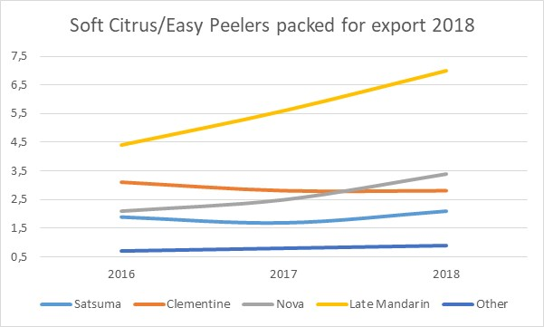
Laat mandaryne oorheers steeds hierdie kategorie - styg tot 7 miljoen kartonne in 2018. Novas is nou nommer twee (3,4 m), wat die clementines (2.8 m) verby gegaan het. Satsumas bly redelik stabiel op 2.1 m kartonne.

GEPAK EN VERSKEEP
Tot Week 44  Miljoen 15 Kg Kartonne | Gepak | Gepak | Gepak | Verskeep | Verskeep | Aanvanklike Skatting | Nuutste Voorspelling | Finaal Gepak
Bron: PPECB/Agrihub | 2016 | 2017 | 2018 | 2017 | 2018 | 2018 | 2018 | 2017
Pomelo’s | 13.8 m | 15.7 m | 18.7 m | 15.4 m | 18.1 m | 16.8 m | 18.7 m | 15.7 m
Sagte Situs | 12.2 m | 13.4 m | 16.1 m | 13 m | 15.8 m | 14.7 m | 16.2 m | 13.4 m
Suurlemoene | 15 m | 19 m | 19.8 m | 18.8 m | 19.3 m | 20.6 m | 19.9 m | 19 m
Nawels | 26.2 m | 21.1 m | 26.6 m | 21.1 m | 26.3 m | 25.7 m | 26.6 m | 21.1 m
Valencias | 42 m | 53.8 m | 53.9 m | 52.9 m | 52 m | 53.9 m | 54.1 m | 53.8 m
Totaal | 109.2 m | 123 m | 135.1 m | 120.9 m | 131.4 m | 131.7 m | 135.5 m | 123 m

DIE CGA GROEP VAN MAATSKAPPYE (CRI, RIVER BIOSCIENCE, XSIT, CGA CULTIVAR COMPANY, CGA GROWER DEVELOPMENT COMPANY & CITRUS ACADEMY) WORD DEUR SUIDER-AFRIKA SE SITRUSPRODUSENTE BEFONDS

