UIT DIE PEN VAN DIE CEO (43/18)
(Volg my op Twitter justchad_cga)

Justin Chadwick 26 Oktober 2018
“Agriculture is the most healthful, most useful and most noble employment of man” George Washington
Met net 100,000 kartonne van die geskatte 19,9 miljoen 15kg kartonne suurlemoene wat nog gepak moet word, behoort die finale volume net 3% onder die Maart skatting te wees – wel gedaan Suurlemoen Fokusgroep. Die 2018 suurlemoen-oes wat vir uitvoer gepak is, sal 'n rekord wees - net minder as 1 miljoen kartonne meer as die 2017 volume. Nie net was die totaal amper soos geskat nie – so was baie van die streke se skattings ook. Die grootste streek (Sondagsrivier) teen 8,65 miljoen kartonne was 1,7% meer as die skatting; Senwes teen 4,13 m kartonne was 8% onder skatting; terwyl Boland teen 1,2 m kartonne 4% onder die skatting was.

2018 SUURLEMOEN SEISOEN OORSIG

Daar was 'n paar verskuiwings in uitvoerbestemmings van suider-Afrika se suurlemoene in terme van die streke. Die Midde-Ooste het in beide absolute terme (7,5 m kartonne in 2017 tot 6.7 m in 2018) en persentasie terme afgeneem (40% tot 35%). Dit was ook die geval in Suid-Oos Asië waar volumes van 3 m (2017) tot 2,3 m (2018) afgeneem het. Europa het van hierdie vrugte opgeneem (van 3,8 m tot 5,6 m, van 20% in 2017 tot 29% in 2018); so ook het die VK - 1,4 m (7%) tot 1,7 m (9%). Rusland het ook 'n effense daling beleef - van 2 m (11%) in 2017 tot 1,8 m (9%) in 2018; terwyl Noord-Amerika van 0,8 m na 0,9 m toegeneem het (4 tot 5%). Met betrekking tot individuele lande het Nederland (3,2 miljoen 15 kg kartonne)
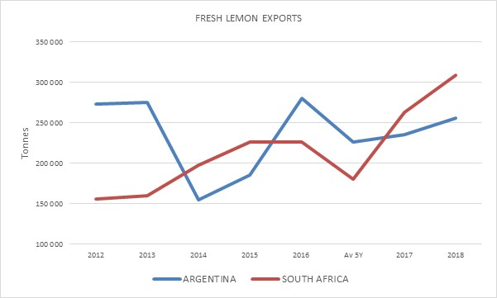
die VAE verbygegaan (3 m). Saoedi-Arabië (1.9m) is net voor Rusland (1,8m), met die VK (1.6m) wat die top vyf afrond.
Die meeste bronne lys lemmetjies en suurlemoene saam. Met betrekking tot uitvoervolumes, is dit veilig om aan te neem dat Meksiko hoofsaaklik lemmetjies is, wat Spanje laat as die nommer een uitvoerder van suurlemoene in die wêreld (0.55 m ton). Turkye (0.45 m ton) volg op nommer twee, terwyl Suid-Afrika en Argentinië mekaar op drie en vier afwissel (tussen 0.25 en 0.3 miljoen ton).

DAFF SITRUS KOӦRDINERINGSVERGADERING
Welgedaan aan Ernest Phoku en sy span van DAFF – professioneel en goeie aanbiedings soos die sitrusbedryf ‘n egte publieke – privaat vennootskap omarm. Hierdie koördineringsvergaderings het jare gelede begin - en aanvanklik was die uitdaging om die bedryf te kry om by te woon. Die uitdaging is nou om die bedryf te kry om te RSVP - die 90 wat wel bevestig het, was ver minder as die 240 wat die saal by Loskop Forever oord gevul het. 'n Groot opkoms van die bedryf - met al die elemente in die waardeketting wat bygewoon het. Vir diegene wat nie kon bywoon nie, gaan DAFF nou hierdie inligting op 'n roadshow neem; asseblief RSVP sodat ons kan verseker dat die lokale jul kan akkommodeer. 29/10 om 09:00 by Musina Landbou Saal, Skougronde; 30/10 Tzaneen Country Lodge 09:00; 31/10 Hoedspruit Hengelklub 10:00; 1/11 Nelspruit CRI Raadsaal 09:00; 5/11 KZN FPT Opleidingslokaal 09:00; 6/10 Africanos Sondagsrivier om 09:00 en 8/11 Stellenbosch LNR Infruitec om 09:00.

GEPAK EN VERSKEEP
Tot Week 42  Miljoen 15 Kg kartonne | Gepak | Gepak | Gepak | Verskeep | Verskeep | Aanvanklike Skatting | Nuutste Voorspelling | Finaal Gepak
BRON: PPECB/Agrihub | 2016 | 2017 | 2018 | 2017 | 2018 | 2018 | 2018 | 2017
Pomelo’s | 13.8 m | 15.7 m | 18.7 m | 15.4 m | 18.1 m | 16.8 m | 18.7 m | 15.7 m
Sagte Sitrus | 12.2 m | 13.4 m | 16.1 m | 13 m | 15.8 m | 14.7 m | 16.2 m | 13.4 m
Suurlemoene | 15 m | 19 m | 19.8 m | 18.8 m | 19.3 m | 20.6 m | 19.9 m | 19 m
Nawels | 26.2 m | 21.1 m | 26.6 m | 21.2 m | 26.3 m | 25.7 m | 26.6 m | 21.1 m
Valencias | 42 m | 53.7 m | 53.8 m | 50.4 m | 48.4 m | 53.9 m | 54.1 m | 53.8 m
Totaal | 109.2 m | 122.9 m | 135 m | 118.8 m | 127.9 m | 131.7 m | 135.5 m | 123 m

DIE CGA GROEP VAN MAATSKAPPYE (CRI, RIVER BIOSCIENCE, XSIT, CGA CULTIVAR COMPANY, CGA GROWER DEVELOPMENT COMPANY & CITRUS ACADEMY) WORD DEUR SUIDER-AFRIKA SE SITRUSPRODUSENTE BEFONDS

