UIT DIE PEN VAN DIE CEO (44/18)
(Volg my op Twitter justchad_cga; nou ‘n 1 000 wat my volg!!))

Justin Chadwick 2 November 2018
“If Twitter, Youtube, and Google were part of my school subjects, my parents would be so proud of me” Anon

2018 NAWEL SEISOEN SE OORSIG
Om die tendens te volg, het nawels ook ‘n rekord uitvoervolume beleef - teen 26,6 miljoen kartonne net meer as 2016 (26,2 m). Dit was net 4% meer as Maart se skatting. Vóór die Nawel Fokusgroep geluk gewens word, is dit nodig om aan te dui dat daar groot veranderinge in die streke was - Senwes is steeds die grootste streek met 8.8 m kartonne - 'n reuse 34% meer as skatting, terwyl Sondagsrivier na die derde grootste streek geskuif het met ‘n 5.1 m karton uitvoervolume, 15% minder as skatting. Dit is die Wes-Kaap wat die tweede plek verower het - hul 6.1 m kartonne was amper in die kol met hul skatting. Patensie was 11% minder as skatting (3 m teen 3,4 m), terwyl Nelspruit 3% minder as skatting was (1.6m teen 1,7 miljoen).
In terme van streeksverspreiding, ‘n afname in Europa (vanaf 30% in 2017 tot 26% in 2018) is deur die Midde-Ooste opgeneem (23% tot 26%). Verspreiding na ander dele het nie wesenlik van 2017 verskil nie - Suidoos-Asië 18%, Noord-Amerika 15%, Rusland en die VK beide 5% en Asië 3%. Net soos met pomelo's en suurlemoene, het Nederland die nommer een invoerder gebly met 4,2 miljoen kartonne. Hulle is deur Saoedi-Arabië (2,9 m), UAE (2,5 m) en VSA (2,4 m) gevolg. Van nêrens het China ‘n verskyning op nommer 5 gemaak - styg van 0,8 m kartonne in 2017 tot 2 miljoen kartonne in 2018.
SUIDER-AFRIKA SE SITRUSUITVOERE BEREIK 2 MILJOEN TON
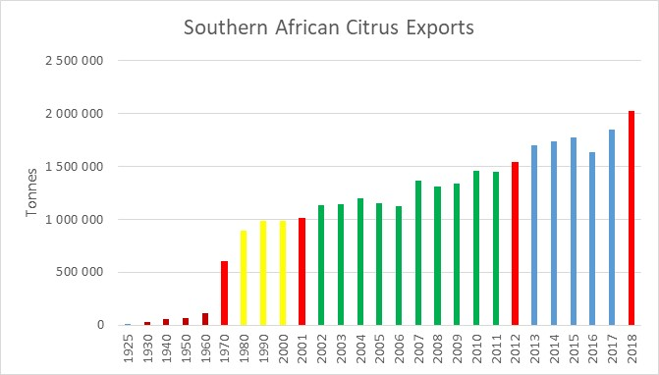
Ek kan soos gister onthou toe die sitrusbedryf 1 miljoen kartonne bereik het - ek was ‘n lid van 'n paneel by die Southern Hemisphere Fruit Conference en Chris White het my gevra of dit ‘n rede is om te vier of nie. Die antwoord was beide – ‘n rede om te vier en te bekommer; ‘n groeiende bedryf was ‘n goeie ding vanaf ‘n produksie oogpunt, maar as ons faal om mark-aanvraag teen dieselfde pas te groei, sal probleme opduik.
Die bedryf het nou 2 miljoen ton bereik, en dieselfde gevoelens is nog daar. Die pas van groei is besig om te versnel; waar dit die eerste 60 jaar geneem het om 500 000 ton te bereik, het die volgende stap na 1 miljoen ton 31 jaar geneem en van 1 tot 1,5 was dit 12 jaar; die laaste toename van 500 000 ton het net 6 jaar geneem (en voorspellings toon dat die volgende 500 000 ton 3 jaar sal neem).
SITRUS KORTKURSUS
Die Citrus Academy het nog 'n Sitrus Kortkursus werkswinkel ingesluit, wat op 25-26 Februarie 2019 by die Hoedspruit-hub gaan plaasvind. Besoek gerus die webwerf van die Citrus Academy om te registreer en vir meer inligting: www.citrusacademy.org.za.
GEPAK EN VERSKEEP
Tot Week 43  Miljoen 5 Kg Kartonne | Gepak | Gepak | Gepak | Verskeep | Verskeep | Aanvanklike Skatting | Nuutste Voorspelling | Finaal Gepak
BRON: PPECB/Agrihub | 2016 | 2017 | 2018 | 2017 | 2018 | 2018 | 2018 | 2017
Pomelo’s | 13.8 m | 15.7 m | 18.7 m | 15.4 m | 18.1 m | 16.8 m | 18.7 m | 15.7 m
Sagte Sitrus | 12.2 m | 13.4 m | 16.1 m | 13 m | 15.8 m | 14.7 m | 16.2 m | 13.4 m
Suurlemoene | 15 m | 19 m | 19.8 m | 18.8 m | 19.3 m | 20.6 m | 19.9 m | 19 m
Nawels | 26.2 m | 21.1 m | 26.6 m | 21.2 m | 26.3 m | 25.7 m | 26.6 m | 21.1 m
Valencias | 42 m | 53.8 m | 53.9 m | 50.9 m | 51.8 m | 53.9 m | 54.1 m | 53.8 m
Totaal | 109.2 m | 123 m | 135.1 m | 119.3 m | 131.3 m | 131.7 m | 135.5 m | 123 m

DIE CGA GROEP VAN MAATSKAPPYE (CRI, RIVER BIOSCIENCE, XSIT, CGA CULTIVAR COMPANY, CGA GROWER DEVELOPMENT COMPANY & CITRUS ACADEMY) WORD DEUR SUIDER-AFRIKA SE SITRUSPRODUSENTE BEFONDS

