FROM THE DESK OF THE CEO (8/20)
(Follow me on Twitter justchad_cga)
Justin Chadwick 6 March 2020
“Non one can make you feel inferior without your consent” Eleanor Roosevelt
CGA BOARD
CGA Board Directors are elected by their regions for a two-year period. The resignations of Fanie Meyer and Pieter Nortje (see Newsletter 3/20) means that Tommie Landman (Hoedspruit) and Hennie Ehlers (Sundays River) will join the Board from the beginning of April 2020.
Other Board members who were reelected by their respective regions are as follows: Jock Danckwerts (East Cape Midlands), Ben Vorster and Jan Louis Pretorius (Letsitele), Guy Whitaker (Limpopo River), Phillip Dempsey (Patensie), Charles Rossouw and Pieter Engelbrecht (Senwes), Paul Bristow (Zimbabwe) and Hannes de Waal (Sundays River).
The CGA Board will meet on 24 and 25 March – where the different office bearers will be elected.

CGA LEVY REFERENDUM
Thank you to all those growers who have completed and returned the CGA Referendum forms. CGA is in the process of capturing the returns.
It is important that we get the feedback from ALL growers. As a result, CGA had extended the date for receiving referendum forms through to Friday 13 March 2020 – which will allow the CGA Board to discuss the referendum results at the CGA Board meeting scheduled for 24/25 March 2020.
Should you need a referendum form please contact gloria@cga.co.za. Completed forms can be faxed to 031-7658029 or scanned and mailed to justchad@iafrica.com
WOLD CITRUS ORGANISATION – THE RATIONALE
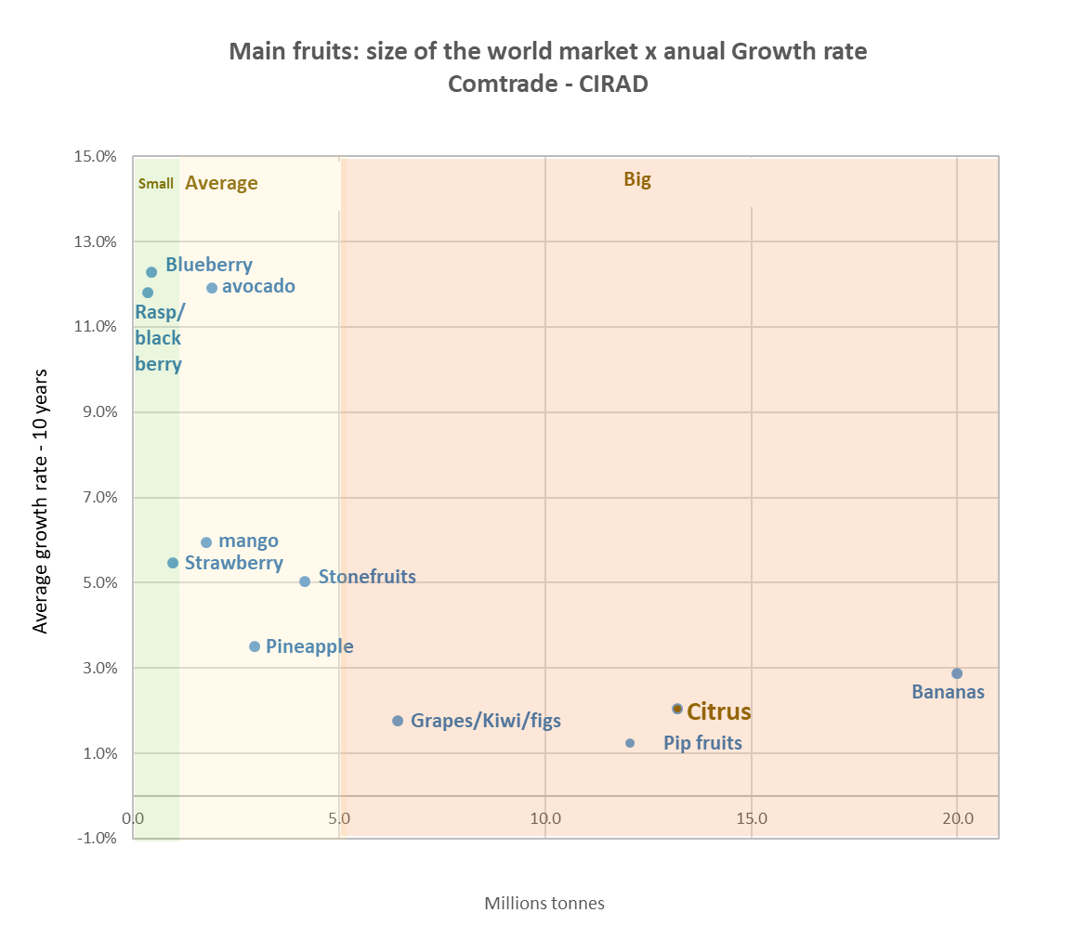
One of the reasons for forming the WCO was to promote the citrus sector. Eric Imbert of CIRAD presented some very interesting data supporting the need for such a platform. This graph shows that big does not necessarily mean better. The biggest volume fruit categories are bananas and citrus. However, the average growth rate over the past ten years for these categories (as well as others in the big category like pip fruits, grapes and kiwis) is less than 3%. This is in stark contrast to sectors such as avocado, blueberry and raspberry which are growing at between 11 and 13%.
The citrus sector needs to get on a higher growth path to soak up the anticipated additional supply.

