FROM THE DESK OF THE CEO (1/19)
(Follow me on Twitter justchad_cga)

Justin Chadwick 4 January 2019
“Those who say it can not be done, should not interrupt those doing it” Chinese Proverb

DON’T MISS THE 2019 CGA CITRUS SUMMIT
Three high powered international speakers will be presenting at the CGA Citrus Summit to be held at the Boardwalk Conference Centre in Port Elizabeth from 12 to 14 March 2019 (visit www.cga.co.za) .
Prof Marcos Neves is widely regarded as the expert on value chains. Coming from Brazil, Prof Neves has done considerable work in the citrus industry – and has written widely on the citrus supply chain.
Philippe Binard has been involved in the European fresh produce industry forever. As General Delegate of Freshfel (representing EU importers and exporters), Philippe has wide experience on government policy and advocacy, statistics on trade flows and the intricacies of trading with the EU. Philippe’s presentation will cover the global citrus situation, and what that all means for the southern African citrus industry.
Richard Bright’s Reefer Trends is widely read and recognized as a thought leader in the maritime world. With southern African citrus volumes on the increase, and challenges mounting in terms of cost and availability of long distance trade, Richard will give insights into what to expect in the future.
Not to be outdone by the international presenters, we will also have home grown talent on display. John Purchase has become a word of reason and a source of calm as agriculture faces many challenges. In the political advocacy space the presence of John at high level discussions means that a reasoned approach is taken – John will unpack some of the more pressing government requirements facing the citrus industry. And then we have the highly acclaimed Wandile Sihlobo – as an agricultural economist, Wandile has risen to the top of his field in a very short time. Peter Schlebusch from Standard Bank will provide delegates with some pointers in terms of the economy.
The CGA Citrus Summit will tackle some of the more critical (and sometimes sensitive) topics facing the southern African citrus industry. The threat of HLB (Asian Greening) is one that springs to mind – this will be covered by Vaughan Hattingh. Worker rights is another – Retha Louw (SIZA) will cover some of the tools at grower disposal, with some real life experiences provided by a few citrus growers. The challenges and opportunities faced by black growers in South Africa will be covered in one of the sessions. A panel will also discuss market development – a topic that was debated at the 2017 Summit and remains a topic of debate. The CGA’s representatives in USA, Russia and EU will also be on hand to bring the latest developments.

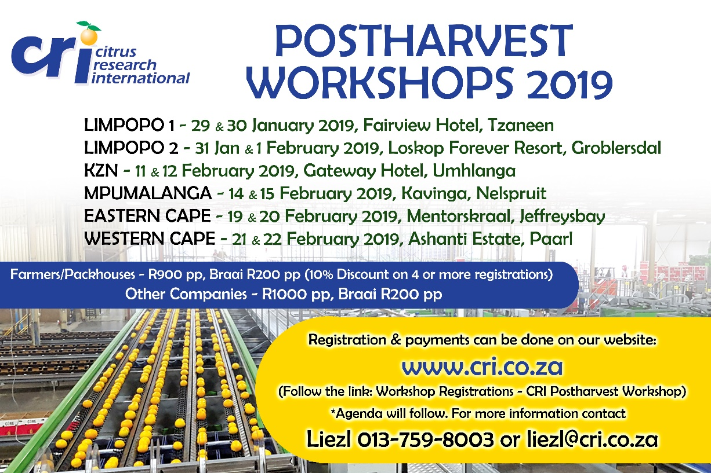

CGA GROUP OF COMPANIES (CRI, RIVER BIOSCIENCE, XSIT, CGA CULTIVAR COMPANY, CGA GROWER DEVELOPMENT COMPANY & CITRUS ACADEMY) ARE FUNDED BY SOUTHERN AFRICAN CITRUS GROWERS

