FROM THE DESK OF THE CEO (13/18)
(Follow me on Twitter justchad_cga)
Justin Chadwick 30 March 2018
“If you think you understand what I am saying, you don’t understand what I am saying” Alan Greenspan
CHANGES AT CITRUS GROWERS’ ASSOCIATION OF SOUTHERN AFRICA (CGA) BOARD
After six years as leader of CGA, Pieter Nortje has stepped down as Chairman. Ben Vorster, incoming Chairman, thanked Pieter for his hard work and dedication through some difficult periods in the industry. Pieter’s dedication to solving industry challenges, his foresight and intense focus on industry issues has meant that the industry continues to grow. Pieter, as outgoing Chairman continues as a member of the Executive Committee as Vice Chairman. As agreed at the 2017 CGA AGM, a further Vice Chairman position was created for succession planning – Cornel van der Merwe continues in this role. George Hall and Fanie Meyer round off the Executive Committee.
Bertus Dilman also resigned from the Board as representative of Limpopo River – Bertus served for five years, and will be remembered for his sage advice and understanding. Guy Whitaker is his replacement. In terms of the constitution, the Senwes region now have two Board members – with Piet Engelbrecht voted in as the second Board member from that region. The CGA welcomes these new appointments, and looks forward to their contribution in the years ahead.
THE ECONOMICS OF LEMONS
In my first year at University, our economics lecturer said, “look to your left, and now look to your right, only one of you will be here next year”. I must have done something right as I was there for economics 1, 2, 3 and masters. What I remember most about that first year was drawing demand and supply curves. It was drummed into us so much that we could draw demand and supply curves in our sleep.
The axis are price per unit on the vertical axis, and then quantity per time on the horizontal axis. Obviously, as the price increases suppliers would be prepared to supply more, whereas consumers would demand less. Where the two curves intersect is the equilibrium price (graph 1). Then we were introduced to a lovely Latin phrase – ceteris paribus – meaning all other things remaining the same. If something changes – such as weather events affecting supply, or an economic meltdown affecting demand, then the curves will shift to the left or right.
A product is deemed inelastic in demand if the amount demanded changes very little, even though the price may fluctuate considerably (graph 2). Lemons are a classic example of a product with inelastic demand. Consumers will buy a set amount of lemons no matter what – if the price halves it will not entice them to buy more, whereas if the price doubles they will purchase the same quantity.
The big increase in the lemon price can be explained using demand and supply curves. The supply curve shifted to the left due to global shortages brought about by climatic conditions (graph 3), while new users and uses of lemons shifted the demand curve to the right – with a concomitant increase in prices. The likelihood of a shift in the supply curve to the right because of more favourable climatic conditions will bring the price down as rapidly as the price increased.
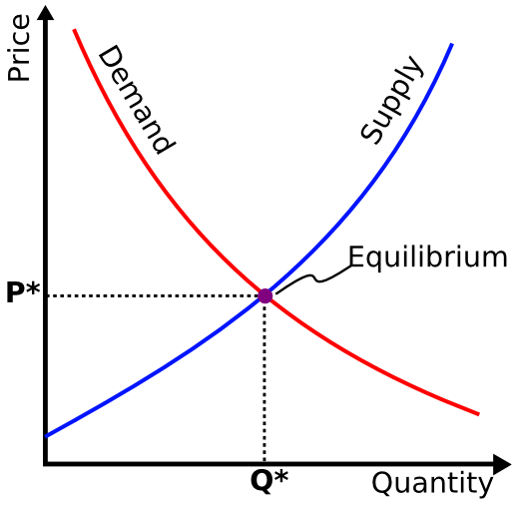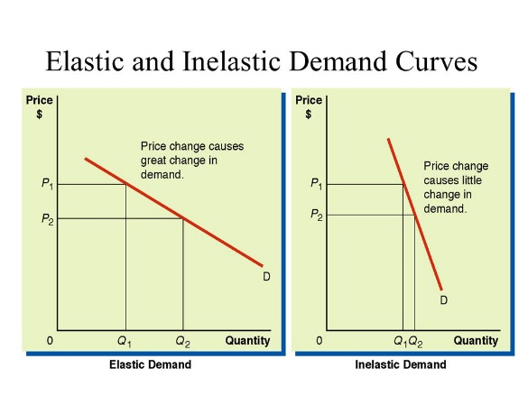
SOFT CITRUS PREDICTION FOR 2018
The Soft Citrus Focus Group met on Tuesday, and in an early correction to the 2018 export volume estimate hiked the prediction from 14.7 m cartons to 15.9 million cartons – meaning that the total southern African citrus export prediction now stands just below 133 million cartons. Clementine volumes increased by 0.2 m cartons, while mandarins increased by a significant 1 million cartons.
CGA GROUP OF COMPANIES (CRI, RIVER BIOSCIENCE, XSIT, CGA CULTIVAR COMPANY, CGA GROWER DEVELOPMENT COMPANY & CITRUS ACADEMY) ARE FUNDED BY SOUTHERN AFRICAN CITRUS GROWERS

