***FROM THE DESK OF THE CEO (48/19)***

**(Follow me on Twitter justchad_cga)**

*Justin Chadwick 29 November 2019*

|  |
| --- |
| ***“Either you run the day, or the day runs you.”- Jim Rohn*** |

**2019 VALENCIA SEASONAL REVIEW (Prepared by Portia Magwaza; CGA Research Economist)**

Initial estimates put the valencia packed for export figure at 46.8 million cartons- well below 2018 (54 m) and 2017 (53.9 m) levels. This was due to unmarketable sizes – big sizes and small.

Estimating the 2019 valencia crop proved to be challenging for many of the Valencia Focus Group members. The initial estimate was 52.9 million cartons- the final tally being almost 12% under the estimate.

The biggest region (Letsitele) at 12.2 million cartons was 17% under the estimate; Sundays River Valley at 6.1 million cartons was 1% over the estimate; while Senwes at 5.2 million was 24% under the estimate. Hoedspruit with 4.8 m cartons was 15% under the estimate and Limpopo River (4.6 m) was 14% less than the estimate.

As with grapefruit, lemons and navels, Netherlands remains the number one importer at 157 000 tonnes. They were followed by China (65 000 tonnes), Russia (45 000 tonnes), UAE (42 000 tonnes) and UK (39 000) rounding the top five importing countries.

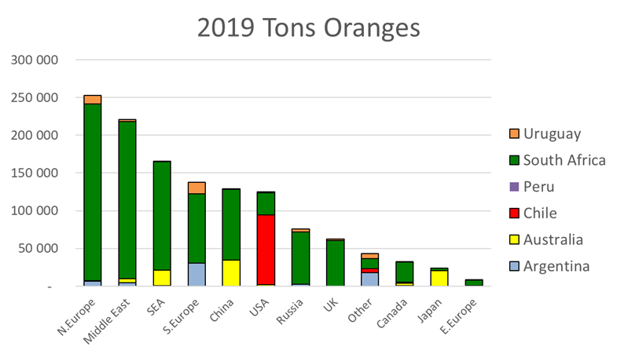

SHAFFE (Southern Hemisphere Association of Fresh Fruit Exporters) figures do not differentiate between different orange types. South Africa dominates the southern hemisphere orange category. The only meaningful competition is in the USA (where Chile dominates) and Japan (led by Australia).

Northern Europe remains the leading importer of southern hemisphere oranges, followed by Middle East and South East Asia.

**DATES FOR 2020**

Diaries are already out for 2020 – later newsletters will have more details, but please take note of the following: CRI Post Harvest Workshops 28-31 January, 3-7 and 11-14 February; CGA Grower Roadshows 10-14 and 17-21 February; AgBIZ Congress 15-17 July; CRI Research Symposium 24-28 August.