FROM THE DESK OF THE CEO (35/20)
(Follow me on Twitter justchad_cga)
Justin Chadwick 28 August 2020
“The greatest enemy of knowledge is not ignorance, it is the illusion of knowledge” Stephen Hawking
THIS IS WHAT TWO MILLION TONNES OF CITRUS LOOKS LIKE
In this newsletter on 7 August 2020 we unpacked some information on what 2 million cartons of citrus looked like (which was achieved in 2018). This information was compiled by Burgert van Rooyen.
To date in 2020, the industry has packed and has approved for export 1,94 million cartons; the latest prediction is 2,14 million tonnes. Some people (like me) prefer pictures to words – so this is what it looks like.
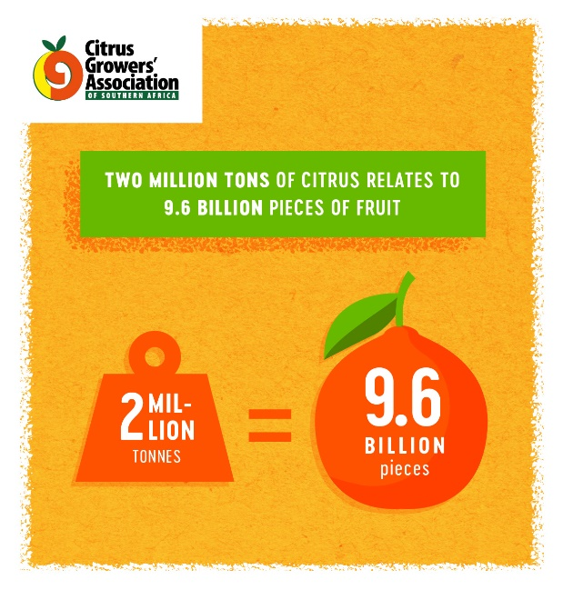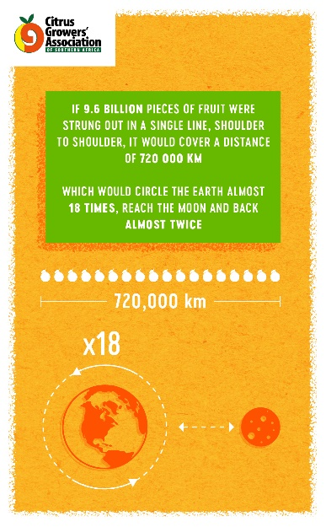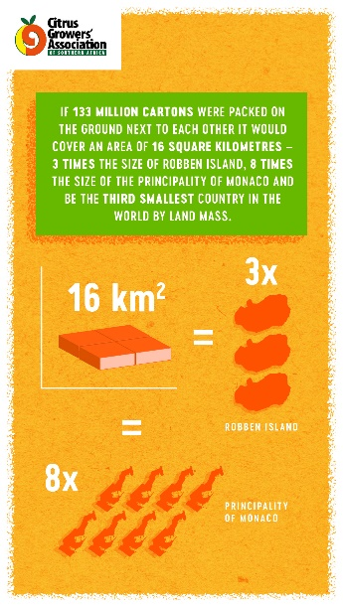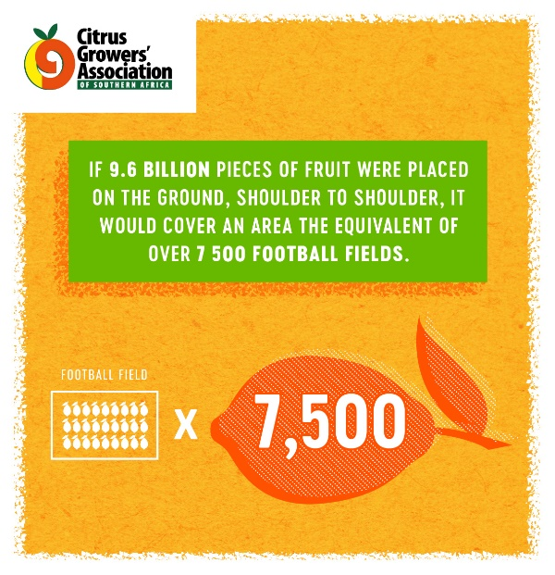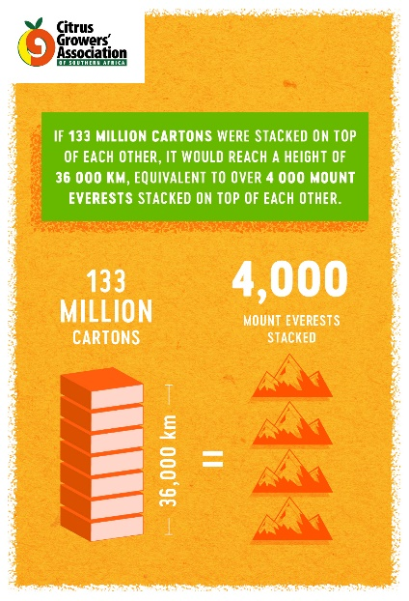
PACKED AND SHIPPED
Million 15 Kg Cartons to end Week 34 | Packed | Packed | Packed | Shipped | Shipped | Original Estimate | Latest Prediction | Final Packed
SOURCE: PPECB/AgriHub | 2018 | 2019 | 2020 | 2019 | 2020 | 2020 | 2020 | 2019
Grapefruit | 19.5 m | 16.1 m | 15.2 m | 14.8 m | 14 m | 16.7 m | 15.2 m | 16.1 m
Soft Citrus | 14.8 m | 16.9 m | 21.4 m | 14.8 m | 19.3 m | 23.3 m | 23.5 m | 18.3 m
Lemons | 18.3 m | 20.7 m | 27.7 m | 17.6 m | 22.5 m | 26.4 m | 28.2 m | 22.1 m
Navels | 25.9 m | 22.7 m | 25 m | 19.6 m | 21.5 m | 26.5 m | 25.9 m | 24.3 m
Valencia | 33 m | 31.5 m | 39.8 m | 22.1 m | 27.6 m | 50.4 m | 50 m | 46.8 m
Total | 111.5 m | 107.9 m | 129.1 m | 88.9 m | 104.9 m | 143.3 m | 142.8 m | 127.5 m

