FROM THE DESK OF THE CEO (32/21)
(Follow me on Twitter justchad_cga)
Justin Chadwick 27 August 2021

“Facts do not cease to exist because they are ignored” Aldous Huxley
VACCINATIONS
The Minister of Agriculture, Land Reform and Rural Development (DALRRD), the Honourable Thoko Didiza, singled out the citrus industry on national television when thanking the agricultural sector for their contribution to getting farm workers vaccinated. This after the publicity around vaccinations on citrus farms in Limpopo and Mpumalanga – and now Western Cape is also gearing up to vaccinate on farms in the Citrusdal and Boland area. DALRRD have asked that we keep them updated on citrus workers being vaccinated. Please could growers who have assisted in vaccinating workers advise Jacomien de Klerk jacomien@citrusacademy.org.za . CGA has asked AGBIZ to engage with provincial Departments of Health so as to get a contact person (hotline) whom growers can call in order to offer a vaccination site, find out where the closest vaccination site is to assist workers in getting vaccinated, or get general vaccination information.
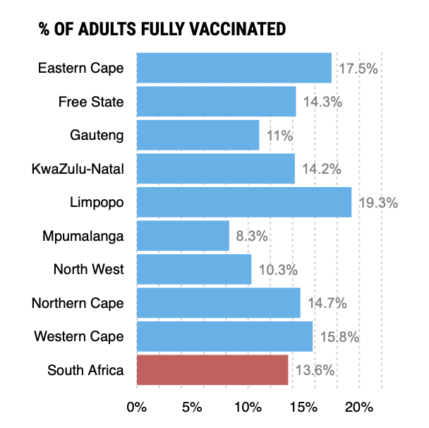
A good source to follow for vaccination update is Bhekikisa (@Bhekikisa_MG). The latest statistics show that almost 14% of the South African adult population is now fully vaccinated – with Limpopo leading the way with 19.3%.
CONGESTION IN DURBAN PORT
As I write this 42 knot winds are buffeting the CGA offices just west of Durban. As a result, the Durban port has gone wind bound. And it could not have come at a worse time – a congested port needs to work hard to clear – not come to a standstill. While there is nothing we can do about the weather, we can do something about the congestion – and that is to not add to it. CGA is sending out to growers information on the status of the port, and recommends that growers liaise closely with their logistics chain partners to reduce the risks associated with the congestion.
PACKED AND SHIPPED
80% of the predicted 2021 export volume is now packed and passed for export. Grapefruit is all but done; while most export regions have received similar volumes of grapefruit when compared to 2020, it is South East Asia (predominantly China) that has grown with 1,9 million cartons in 2020 increasing to 2,8 million in 2021. There have been slight increases in EU (5,3 m to 5,5 million 15 Kg cartons); Asia (1,8 m to 1,9m); North America (0,5 m to 0,8 m); UK (0,6 m to 0,7 m) and Middle East (0,2 m to 0,3 m). Russia showed a slight decrease from 1,1 m to 1m.
End of Week 33  Million 15 Kg Cartons | Packed | Packed | Packed | Shipped | Shipped | Original Estimate | Latest  Prediction | Final Packed
SOURCE: PPECB/AGRIHUB | 2019 | 2020 | 2021 | 2020 | 2021 | 2021 | 2021 | 2020
Grapefruit (17kg) |  |  | 15 m |  | 13.4 m
Grapefruit | 16.3 m | 14.4 m | 17 m | 13.2 m | 15.2 m | 18 m | 17.2 m | 15.5 m
Soft Citrus | 16.1 m | 20.6 m | 25.9 m | 18.4 m | 21.5 m | 30.5 m | 30.2 m | 23.6 m
Lemons | 20.4 m | 26.1 m | 28.3 m | 24 m | 25.9 m | 30.2 m | 28.5 m | 29.6 m
Navels | 22.1 m | 24.2 m | 25 m | 21.6 m | 22 m | 26.3 m | 26.2 m | 26.2 m
Valencia | 24.4 m | 30.4 m | 29.3 m | 22 m | 19.1 m | 58 m | 55.2 m | 55.1 m
Total | 99.3 m | 115.7m | 125.5m | 99.2 m | 103.7 m | 163 m | 157.3 m | 150 m

