FROM THE DESK OF THE CEO (21/18)
(Follow me on Twitter justchad_cga)
Justin Chadwick 25 May 2018
“The wise speak only of what they know” J R R Tolkien

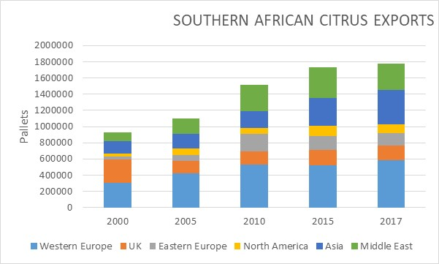
Last week’s newsletters expressed export destinations in terms of percentages – to show the growth in those markets targeted by the industry. This left some with the impression that exports to some destination had decreased. Although this is true for the UK (from about 300 000 pallets to less than 200 000), exports to all other markets have increased from 2000 to 2017. Exports to Western Europe doubled (from 300 to 600 000 pallets). Asia almost trebled (from 150 000 to 420 000), as did Middle East (from 110 000 to 320 000). There was considerable growth in Eastern Europe (from 40 000 to 160 000 pallets) and North America (from 40 000 to 110 000 pallets).
PACKED AND SHIPPED
Grapefruit packing is getting into full swing now – with Durban port starting to get very busy. The season was delayed as colour developed – with the Grapefruit Focus Group reporting a tendency towards smaller sizing. The bigger volume of fruit has offset the sizing decrease leaving the prediction just under the original estimate.
And just like that the Satsuma season is over – the 2 047 148 cartons packed is higher (10%) than the original estimate of 1 862 735 cartons. This is also 18% higher than 2017’s 1 737 712 cartons. Roughly 40% of the predicted 3 million cartons of clementines have now been packed.
Navel packing has also been delayed – and is now starting to gather momentum.
The bulk of the shipped grapefruit has been dispatched to Europe (54%) and Asia (28%). Lemons have predominantly been sent to Middle East (44%), Europe (17%) and Asia (15%). Soft Citrus has mostly been sent to UK (39%), Europe (21%) and Russia (20%).

To Week 20  Million 15 Kg Cartons | Packed | Packed | Packed | Shipped | Shipped | Original Estimate | Latest  Prediction | Final Packed
SOURCE: PPECB | 2016 | 2017 | 2018 | 2017 | 2018 | 2018 | 2018 | 2017
Grapefruit | 4.4 m | 6.9 m | 6.2 m | 3.8 m | 3.4 m | 16.8 m | 16.6 m | 15.7 m
Soft Citrus | 4.4 m | 3.4 m | 3.8 m | 2.7 m | 3 m | 14.7 m | 16.2 m | 13.4 m
Lemons | 6.3 m | 7 m | 7.7 m | 5.2 m | 6 m | 20.6 m | 20.3 m | 19 m
Navels | 4.2 m | 2.7 m | 2.4 m | 1.1 m | 1 m | 25.7 m | 25.7 m | 21.1 m
Valencia | 0.1 m | 0.1 m | 0.1 m | - | - | 53.9 m | 53.9 m | 53.8 m
Total | 19.4 m | 20.1 m | 20.1 m | 12.8 m | 13.4 m | 131.7 m | 132.7 m | 123 m

CGA GROUP OF COMPANIES (CRI, RIVER BIOSCIENCE, XSIT, CGA CULTIVAR COMPANY, CGA GROWER DEVELOPMENT COMPANY & CITRUS ACADEMY) ARE FUNDED BY SOUTHERN AFRICAN CITRUS GROWERS

