FROM THE DESK OF THE CEO (34/18)  (Follow me on Twitter justchad_cga)  Justin Chadwick 24 August 2018 | 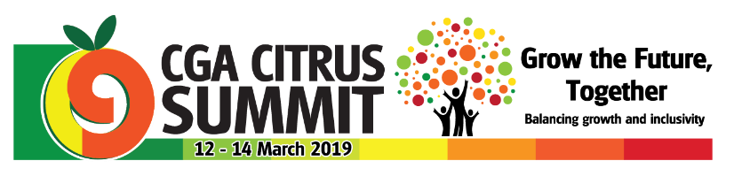
“A women is like a tea bag – you can’t tell how strong she is until you put her in hot water” Eleanor Roosevelt

WOMEN IN AGRICULTURE
Congratulations to Noluthando Mbilase of Greenwood Farm in the Eastern Cape who walked away with the prize for Top Entrepreneur Export markets at DAFF’s recent Women in Agriculture awards ceremony.

CRI RESEARCH SYMPOSIUM
WOW!!! Steve Turner (CRI Board member representing the Fresh Produce Exporters Forum (FPEF)) summed up the CRI Research Symposium in two words – NEXT LEVEL.
CRI took agricultural conferences to the next level –
- The breadth and depth of research reported on was next level. Citrus research in South Africa is not only looking at Plan A, but also Plan B, C and D. The breadth of research in terms of the work in all spheres is impressive, while the depth in terms of the different facets of each research subject addresses an array of aspects. The strength of citrus research is that today’s solutions are based on past research done over the past number of decades, while the work done today will be used for the decades to come.
- Next level in terms of presentations – not only the number of presentations (72 over the three days), but also the quality of the presentations. Congratulations to all speakers – and a special shout out to the students – it is daunting to speak in front of any audience, but when it is to a huge hall full of industry experts it can only be more so.
- Next level in terms of the energy – there was a palpable buzz at all times – a point made by many at the speeches at the gala dinner. There is such a good feeling and positive vibe in the industry; and it generates optimism and enthusiasm.
- Next level in terms of delegates – with over 700 delegates this ranks as the biggest agricultural conference in the country.
- Next level in terms of catering and hospitality. To cater for 700 people for breakfast, lunch, supper and tea break is no small feat. And to do this with no queues and a selection of different options at mealtime is unbelievable. The Champagne Sports Resort have to be commended.
- Next level in terms of networking and hospitality. With both gin and tonics and beer on tap on two evenings, and to top it all the highly acclaimed band Mango Groove playing at the Gala Dinner everybody could enjoy themselves (especially after sitting through the 72 presentations).
- The next level in terms of diversity and portraying our rainbow nation – a good mix of all South Africans, with an impressive array of ladies making presentations. Chris White – the guru on international fresh produce industries once remarked that you can tell the health of an industry by the number of young people in the audience – the southern African citrus industry is incredibly healthy.
- Next level in terms of international collaboration. It was excellent to hear the different accents during the presentations – from all parts of the globe.
I am not sure how CRI is going to surpass this in 2020 – but I am starting to look forward to it already. However, such events do not just happen – there was an incredible amount of work done by the organising committee. Liesl’s attention to detail, and her planning and execution, done in a calm and composed manner was key to the success. The program committee’s ability to choose a range of topics and speakers of cardinal importance meant that the hall was full right through to the final talk. There are just too many people to recognise in this newsletter – well done to all of you.
PACKED AND SHIPPED
Just breached the 100 million cartons packed.
To Week 33  Million 15 Kg Cartons | Packed | Packed | Packed | Shipped | Shipped | Original Estimate | Latest  Prediction | Final Packed
SOURCE: PPECB | 2016 | 2017 | 2018 | 2017 | 2018 | 2018 | 2018 | 2017
Grapefruit | 13.2 m | 15.4 m | 18.2 m | 14.1 m | 16.5 m | 16.8 m | 18.6 m | 15.7 m
Soft Citrus | 11.2 m | 12 m | 14.2 m | 10.8 m | 12.7 m | 14.7 m | 17 m | 13.4 m
Lemons | 14.1 m | 17.9 m | 17.8 m | 17.3 m | 16.5 m | 20.6 m | 19.9 m | 19 m
Navels | 25.4 m | 20.5 m | 25.4 m | 19.9 m | 23.1 m | 25.7 m | 25.4 m | 21.1 m
Valencia | 26.2 m | 32.5 m | 27.8 m | 22.5 m | 16.7 m | 53.9 m | 51.2 m | 53.8 m
Total | 90.2 m | 98.3 m | 103.4 m | 84.3 m | 85.5 m | 131.7 m | 132.1 m | 123 m

CGA GROUP OF COMPANIES (CRI, RIVER BIOSCIENCE, XSIT, CGA CULTIVAR COMPANY, CGA GROWER DEVELOPMENT COMPANY & CITRUS ACADEMY) ARE FUNDED BY SOUTHERN AFRICAN CITRUS GROWERS

