FROM THE DESK OF THE CEO (15/20)
(Follow me on Twitter justchad_cga)
Justin Chadwick 24 April 2020
“Solitude is for me a fount of healing which makes my life worth living. Talking is often a torment for me, and I need many days of silence to recover from the futility of words” Carl Jung
CGA STATISTICS BOOK: RETURNS 2019
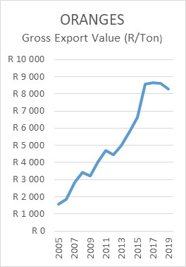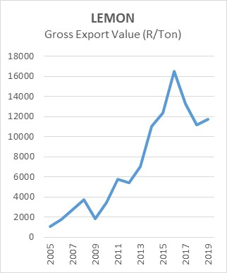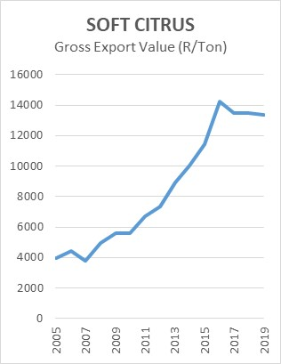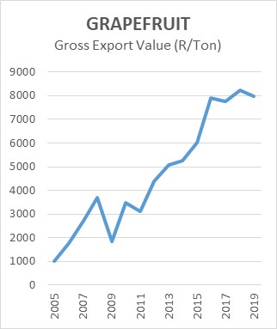
2019 saw a reduction in volume exported from southern African for oranges and grapefruit, while lemons and soft citrus experienced increases in volume exported.
Notwithstanding this decreased volume the gross export value of oranges and grapefruit (all grades to all markets) showed a small decrease, as did soft citrus. Lemons showed a small improvement after the sharp decrease in 2019.
MARKET CONDITIONS: JAPAN
It seems that the sales of food and perishable products has hit the highest levels since 2012; which bodes well for those selling fruit into this market.
