***FROM THE DESK OF THE CEO (47/19)***

**(Follow me on Twitter justchad_cga)**

*Justin Chadwick 22 November 2019*

|  |
| --- |
| ***“Leadership is about vision and responsibility, not power.” – Seth Berkley*** |

**2019 SOFT CITRUS SEASONAL REVIEW (Prepared by Portia Magwaza; CGA Research Economist)**

As the curtain is down on the 2019 soft citrus season, it has been a record in terms of volume packed for export surpassing 2018’s 16.2 million cartons. The initial estimate was for 18.3 million cartons with the final tally being 18.2 million – well done Soft Citrus Focus Group.

The biggest region is Boland with 4.3 million cartons, followed by Western Cape 3.4 million and Patensie (despite water woes) recorded 2.6 million. Sunday River Valley packed 2.5 million cartons while Burgersfort and Ohrigstad packed 1.7 million cartons.

The UK remained the top destination for southern African soft citrus – decreasing from 2018’s 61 900 tonnes to 61 200 tonnes. Netherlands came in second with an increase from 48 000 tonnes to 55 300 tonnes. Russia experiences a slight decrease from 26 400 tonnes to 24 400 tonnes. The fourth position goes to USA – increasing from 12 800 tonnes to 16 600 tonnes as did Bangladesh (10 600 tonnes vs 14 300 tonnes).

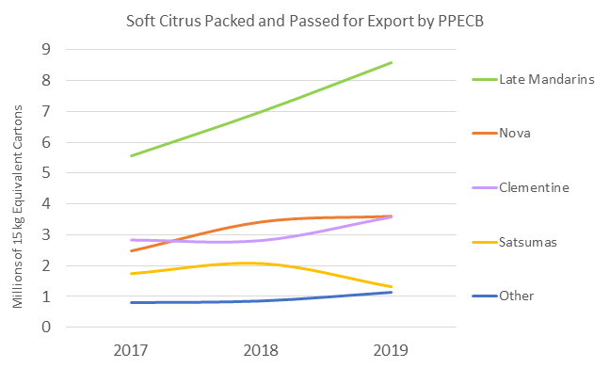

Late mandarins continue to dominate this category- rising to 8.6 million cartons in 2019. Nova’s reached a plateau at 3.6 million cartons. Whilst clementine’s over took the second spot at 3.8 million cartons, Satsuma’s declined at 1.3 million.

Under the auspices of the Southern Hemisphere Association of Fresh Fruit Exporters (SHAFFE) citrus export volume figures are shared on a weekly basis. John Edmonds (CGA Information Manager) has analysed the 2019 figures. USA is the major destination, predominantly serviced by Chile and Peru. South Africa dominated exports to UK, northern and southern Europe, Russia, South East Asia and Middle East. Australia are active in China and Asia. Argentina comes into the mix in Russia. Canada is supplied by South Africa and Peru.

