FROM THE DESK OF THE CEO (16/18)
(Follow me on Twitter justchad_cga)
Justin Chadwick 20 April 2018
“Price is what you pay. Value is what you get” Warren Buffett

EXPROPRIATION WITHOUT COMPENSATION (EWC)
If you own land in Limpopo, Mpumalanga or Eastern Cape you must attend one of these sessions.
As most of you are aware, Parliament recently passed a motion to review Section 25 of the Constitution (Deprivation of Property clause) and for the Constitution Review Committee (CRC) of Parliament to consider “Expropriation without Compensation” (EWC) as a mechanism to speed up and effect greater land reform, but subject to a so-called sustainability test with regard to food security, financial sustainability and economic development. The CRC must submit proposals to Parliament by 30 August, following a thorough consultation process.
It is critically important that CGA members participate in the provincial consultations. To prepare members for the provincial consultation process it is critically important you are updated with the latest developments in this regard.
To this end CGA, Agbiz and Agrilimpopo are hosting EWC Information Session’s in the northern regions (covering Limpopo and Mpumalanga provinces). The first session will be on 24 April 2018 from 14h00 to 17h00 at Tzaneen Country Lodge (please rsvp to Alexan at elimpopo@cga.co.za); while the second session with be on 26 April 2018 from 14h00 to 17h00 at Maroela Game Trails, Groblersdal (please rsvp Lorraine at wlimpopo@cga.co.za) .
To cater for growers in the Eastern Cape a session will be hosted by CGA and Agbiz on Thursday 3rd May at Africanos, Sundays River from 10h00 to 13h00 (please rsvp Leandre at ljooste@srcc.co.za). Summer Citrus will be addressing growers in the Western Cape.
Growers are urged to participate in this process.

AVERAGE EXPORT VALUE OF SOUTHERN AFRICAN CITRUS IN 2017
John Edmonds (CGA Information Manager) is in the process of putting together the CGA Statistics book for 2017. After many years of sustained growth in the average price realized for all sectors of the southern African citrus industry, 2017 delivered a mixed bag. Orange prices showed a marginal increase, while both grapefruit and soft citrus showed decreased average prices. There was a marked decrease in average prices realized in the lemon sector.
Notwithstanding the decreased average prices, and given the record volumes exported in 2017, the gross export earnings increased from R16.2 billion in 2016 to R17.7 billion in 2017 – an increase of 9.2%.
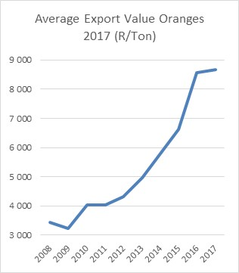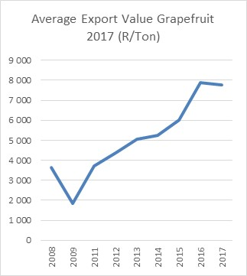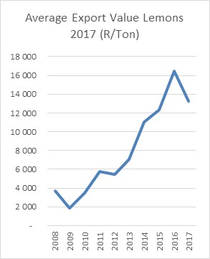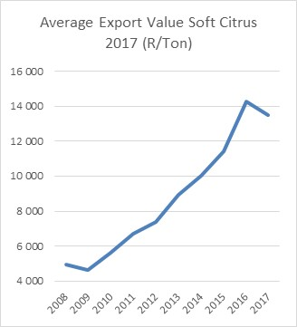
CGA GROUP OF COMPANIES (CRI, RIVER BIOSCIENCE, XSIT, CGA CULTIVAR COMPANY, CGA GROWER DEVELOPMENT COMPANY & CITRUS ACADEMY) ARE FUNDED BY SOUTHERN AFRICAN CITRUS GROWERS

