FROM THE DESK OF THE CEO (20/18)
(Follow me on Twitter justchad_cga)
Justin Chadwick 18 May 2018
“Nobody is superior, nobody is inferior, but nobody is equal either. People are simply unique, incomparable. You are you, I am I.” Osho

2018 EXPORT QUALITY STANDARDS HAVE BEEN GAZETTED
DAFF’s Directorate of Food Safety and Quality Assurance is responsible for setting and implementing the export quality standards for citrus. On 11 May 2018, the recently gazetted citrus export standards for the 2018 season came into effect. The amended standards can be found at the following link: http://www.daff.gov.za/daffweb3/Branches/Agricultural-Production-Health-Food-Safety/Food-Safety-Quality-Assurance/Export-Standards/Citrus-and-Subtropical-Fruit/Citrus-fruit . The main changes to the export standard relate to: 1) the addition of new cultivars to the tables of cultivar names and their carton indications, 2) tolerance for mandarins/soft citrus to the USA, and 3) fruit size requirements for FE1 grapefruit.
EXPORT DESTINATION OF SOUTHERN AFRICAN CITRUS
In the year 2005, 38% of southern African citrus exports went to Western Europe, and 14% to the UK. By 2010, Western Europe had dropped to 35% and the UK to 11%. Last year they accounted for 33% and 10% respectively. The combined volume to EU had dropped from 52% to 43%. Eastern Europe (mostly Russia) increased from 7 to 15% between 2005 and 2010, before dropping down to 9% last year. The Middle East initially grew from 2005 to 2010 (17 to 21%), before dropping to 18% in 2017. The largest growth took place in Asia – although there was a decrease from 17% to 14% between 2005 and 2010, there was growth to 2017 at 24%. The north American share remained static; 7% in 2005, 5% in 2010 and 6% last year.
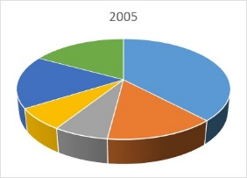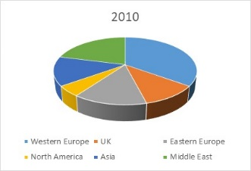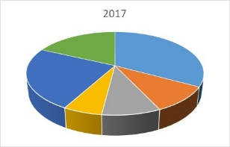

PACKED AND SHIPPED
Ten million cartons (150 000 tons) of citrus has now been shipped – with lemons accounting for 50% of the volume shipped. Middle East is the premier destination with 47%, followed by EU 17%, Asia 16% and Russia 14%. Grapefruit and soft citrus each contribute 25%, with negligible volumes of navels shipped to date. Grapefruit has mostly been sent to EU (57%) and Asia (31%). Soft citrus has been shipped to EU (62%) and Russia (22%).
Rain in the northern and eastern regions of the citrus industry will have slowed packing during the past week.

To Week 19  Million 15 Kg Cartons | Packed | Packed | Packed | Shipped | Shipped | Original Estimate | Latest  Prediction | Final Packed
SOURCE: PPECB | 2016 | 2017 | 2018 | 2017 | 2018 | 2018 | 2018 | 2017
Grapefruit | 3.3 m | 5.3 m | 4.3 m | 2.8 m | 2.4 m | 16.8 m | 16.5 m | 15.7 m
Soft Citrus | 3.6 m | 2.8 m | 3.3 m | 2.2 m | 2.5 m | 14.7 m | 16.2 m | 13.4 m
Lemons | 5.4 m | 5.8 m | 6.7 m | 4.2 m | 5 m | 20.6 m | 20.3 m | 19 m
Navels | 2.5 m | 1.5 m | 1.2 m | 0.5 m | 0.4 m | 25.7 m | 25.7 m | 21.1 m
Valencia | - | - | - | - | - | 53.9 m | 53.9 m | 53.8 m
Total | 14.8 m | 15.4 m | 15.5 m | 9.7 m | 10.3 m | 131.7 m | 132.6 m | 123 m

CGA GROUP OF COMPANIES (CRI, RIVER BIOSCIENCE, XSIT, CGA CULTIVAR COMPANY, CGA GROWER DEVELOPMENT COMPANY & CITRUS ACADEMY) ARE FUNDED BY SOUTHERN AFRICAN CITRUS GROWERS

