FROM THE DESK OF THE CEO (20/17)
(Follow me on Twitter justchad_cga)
Justin Chadwick 18th August 2017
“When life throws you a rainy day, play in the puddles” Pooh Bear
RAINFALL NEEDED IN WESTERN AND EASTERN CAPE
“Don’t be fooled by how green it looks” was the advice from a citrus industry veteran as I travelled through to Citrusdal on Monday. On either side of the freeway green fields of young shoots spread out as far as the eye can see – but this picture hides the true situation. The Western Cape is experiencing its driest year in over 100 years (some say 130). Dam levels are extremely low. The Eastern Cape is experiencing similar conditions. The Sundays River region gets its water from the Gariep dam in the Free State, which is at 72% full – and therefore from an irrigation point of view there is sufficient water, but all growers will tell you that orchards fare much better when watered by nature, and the Eastern Capes winter rainfall was well below average. Patensie region is a different picture – with dams at critically low levels; the Kouga dam is at 16% of capacity.
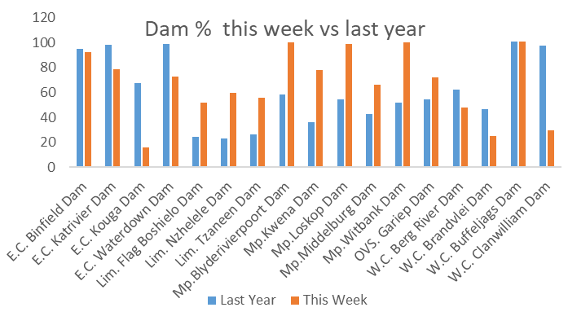
FALSE CODLING MOTH (FCM)
On 14 July, an amendment of the European Union’s Directive on protective measures against the introduction of harmful organisms into the EU was published in the Official Journal of the EU, to include FCM [Commission Directive 2017/1279]. This now means that FCM is officially a regulated pest for the EU and will come into force on 1 January 2018. The regulation states that citrus from Africa, amongst other crops, either must be sourced from an FCM-free area or must be subjected to an effective cold treatment or another effective treatment to ensure freedom from FCM. CRI has developed a scientifically based systems approach as an effective alternative treatment, within an FCM management system (FMS). This system is in the last stages of finalisation, through consultation with representatives from all sectors of our citrus industry, and will be presented in its current form to the industry at the upcoming CRI IPM and Disease Management Workshops in August and September (for dates and venues please contact Liezl van der Linde (liezl@cri.co.za or 013 759 8000) . It is very important that all growers attend these workshops, as the EU regulations affect the next citrus season and the FMS must be implemented as from November this year.
PACKED AND SHIPPED
As we get towards the tail end of the grapefruit and navel seasons, the final predictions have been increased slightly. In contrast, the Lemon Focus Group met yesterday and made significant upward adjustments to the estimate – now at 1 million cartons above initial estimate. There is some concern regarding the final Valencia volume – the Valencia Focus Group will meet to clarify the position.
To End Week 32  Million 15 Kg Cartons | Packed | Packed | Packed | Shipped | Shipped | Original Estimate | Latest  Prediction | Final Packed
SOURCE: PPECB/AGRIHUB | 2015 | 2016 | 2017 | 2016 | 2017 | 2017 | 2017 | 2016
Grapefruit | 14.9 m | 13.2 m | 15.2 m | 11.7 m | 13.4 m | 15.6 m | 15.6 m | 13.2 m
Soft Citrus | 8.5 m | 10.6 m | 11.4 m | 9.2 m | 10.2 m | 13.2 m | 13.6 m | 12.2 m
Lemons | 13.6 m | 13.8 m | 17.7 m | 13.1 m | 16.8 m | 17.5 m | 18.5 m | 15 m
Navels | 22.8 m | 24.7 m | 20.1 m | 21.7 m | 18.9 m | 26.3 m | 20.1 m | 26.2 m
Valencia | 22.7 m | 21.9 m | 28.1 m | 15.4 m | 18 m | 50.1 m | 48.5 m | 41.8 m
Total | 82.5 m | 84.2 m | 92.5 m | 71.1 m | 77.3 m | 122.7 m | 116.3 m | 108.4 m

THE CGA GROUP OF COMPANIES (CRI, RIVER BIOSCIENCE, XSIT, CGA CULTIVAR COMPANY, CGA GROWER DEVELOPMENT COMPANY & CITRUS ACADEMY) ARE FUNDED BY SOUTHERN AFRICAN CITRUS GROWERS

