FROM THE DESK OF THE CEO (50/19)
(Follow me on Twitter justchad_cga)
Justin Chadwick 13 December 2019
“Learn from yesterday, live for today, hope for tomorrow. The important thing is not to stop questioning” Albert Einstein
PORTS REGULATOR (PRSA) DECREASES EXPORT CONTAINER TARIFF BY 20%
Producers are still seeing the benefits of the CGA’s role in bringing awareness to the exorbitantly high port cargo dues tariff some years back. CGA submitted to the PRSA as far back as 2010 that the cargo dues tariff levied by TNPA for export containers was substantially disproportionate against bulk and breakbulk tariffs. The information was used to assist the PRSA in drafting the port tariff strategy that seeks to address imbalances in port cargo dues. This has seen the tariff for export containers reduce significantly over time and a further 20% reduction has been granted by the PRSA for FY2020/21. The below graph highlights the reduction in the tariff for export containers granted by the PRSA against what was applied for by TNPA. The tariff would have essentially doubled over a period of 10 years but has actually more than halved.
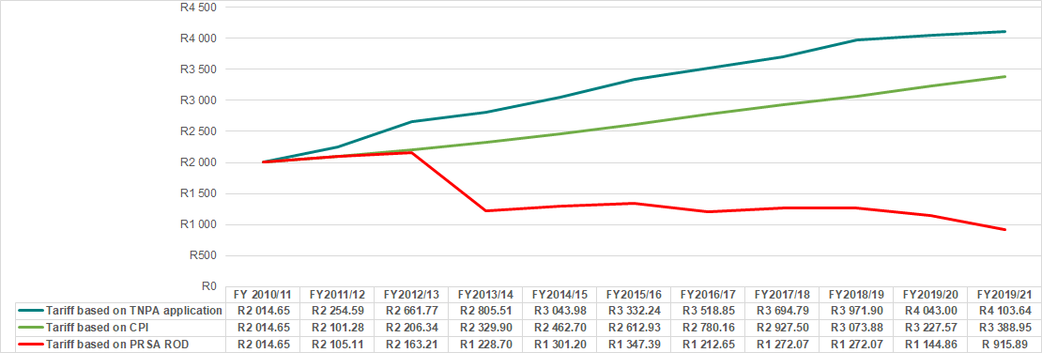
PORTS REGULATOR (PRSA) DECREASES EXPORT CONTAINER TARIFF BY 20%
A few weeks ago I did a bike ride through a sugar cane farm in the Eston area (I know – stupidity runs in the family – back on the bike after my horrific accident). Those who know the area are aware that Eston sugar cane farmers are known for their conservation approach to farming – and this was very evident from the ride. Hillsides that were too steep for cane were covered in pristine grassland, the streams were surrounded by beautiful indigenous forests. This approach to environmental stewardship is also very evident in the citrus industry – visiting a citrus farm is always such a pleasure as it is evident to all that citrus growers in southern Africa farm with nature. They are aware that they are mere custodians of the environment on which they farm. A citrus farm in southern Africa is a thing of beauty – the attention to detail in terms of farm layout, care for streams and rivers and soils makes sense to citrus growers. And the wild animals are allowed to roam – in Citrusdal there is a classic story about baboons that selected the earliest maturing oranges; so much so that the grower selected buds from the trees and developed an earlier maturing cultivar. Farms bordering the Kruger Park have many visitors – elephant are often found in the orchards, and it is said that hippo select only the Star Ruby grapefruit. Probably the most famous story about wild life in orchards is that of the CRI fruit fly expert – when visiting her traps, she found a pair of lions had decided to call an orchard their home. Fortunately, she spotted them while still in her vehicle.
Citrus growers in southern Africa are farming for the future, ensuring that their practices are in harmony with nature.

