***FROM THE DESK OF THE CEO (44/19)***

**(Follow me on Twitter justchad_cga)**

*Justin Chadwick 1 November 2019*

|  |
| --- |
| ***“Our words have power, but our actions shape lives.” – Rachel Hollis*** |

**2019 GRAPEFRUIT SEASONAL REVIEW (Prepared by Portia Magwaza, CGA Research Economist)**

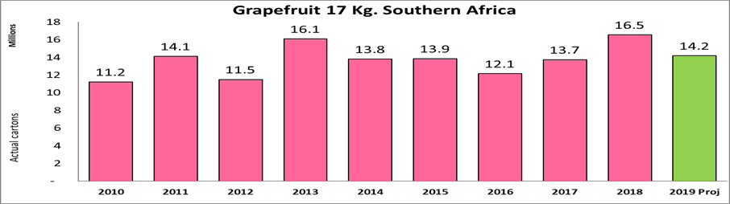Grapefruit packing for export was estimated at 14.2 million cartons (17 kilogram equivalents), almost 14% down on last year’s 16.5 million cartons. This was due to dry conditions in all grapefruit regions. The estimate (prepared in mid-March) also anticipated a predominance of smaller sized fruit.

Estimating the 2019 grapefruit crop proved to be challenging for many of the Grapefruit Focus Group members. The initial estimate was 15.1 million cartons – the final tally being almost 6.3% under the estimate. Within these estimates, some GFG members were way out (Pongola packed 26% more than estimate, Patensie 15%). Onderberg was 17% less than estimated. Others were within the acceptable 10% difference - Oranje River 9% over while Sunday’s River Valley was 10% less than estimated.

Netherlands remains the global leader in terms of importation of the Southern African grapefruit – importing some 70 000 tonnes. China imports have fallen from 52 000 tonnes in 2018, to 35 000 in 2019. China was oversupplied early with small sized fruit and poor colouring which contributed to prices dropping. Japan (29 000), Russian (16 000) and UK (10 000) round out the top five.

**CITRUS PHYTOSANITARY MARKET REGISTRATION**

Citrus growers and packhouses are reminded to register for Phytosanitary markets for the 2020 export season. All registrations should be completed by 13th November 2019, and no late registration will be entertained by DAFF. Registration should be done on the Phytclean website [www.phytclean.co.za](http://www.phytclean.co.za)

**PACKED AND SHIPPED**

