FRESH PLAZA – 10th January

2020Industry hopes that moratorium on hi-cube ban could still be signed, allowing hi-cubes on the road for at least the next 18 months

New year brings unpleasant hi-cube container disappointment for South African fruit and freight industries
Hi-cube 40ft containers, making up around 75% of worldwide container cargo, are currently illegal on South African roads if its height, from the road surface to the top, exceeds 4.3 metres.
It was an unpleasant disappointment to the fruit and freight industries when an extension to the moratorium, that would’ve given another 18 months of grace to hi-cubes on South African roads, was left unsigned before government officials went on holiday.
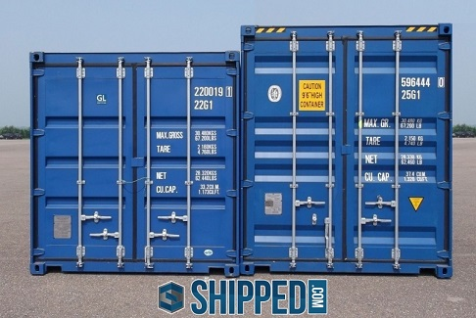A standard container, left, versus a hi-cube on right (photo supplied by Mike Walwyn)
The Department of Transport had earlier given a commitment to the industry that it would extend the moratorium for a ninth year, while the impact of hi-cubes was (again) studied, but nothing to that effect was gazetted before the expiry date of the previous moratorium, 31 December 2019.
The fruit industry experiences a significant increase in table grape export volumes during this time of the year, entering the peak export period between the beginning of January and roughly the first week of March. “This is without mentioning the increase in apples, stone fruit and summer pear export volumes during the same time,” says Werner van Rooyen, operations manager at the Fresh Produce Exporters’ Forum.
“Fresh fruit exporters cannot be held responsible for any consequences which may arise from the agreed-upon extension of the moratorium not having been published in the Government Gazette before the first of January this year.”
The Fresh Produce Exporters’ Forum has sent a letter to the Minister of Transport, Fikile Mbalula, and they are waiting on his response. The extension should have been signed off by his director-general, Alec Moemi, but the latter is still on leave. “That’s incredibly concerning, given the sensitivity of this matter,” Werner says.
At least, industry notes, there have been no reports of trucks pulled over for carrying a hi-cube container.
Impact on South African fruit industry
The South African government contends that hi-cubes are unstable (industry sources say government officials have used examples of overturned trucks carrying standard boxes to bolster its argument) and damage bridges (the same sources say that the South African National Roads Agency has confirmed that there are no bridges lower than 5 metres on South African national roads).
There are not enough standard boxes available to replace hi-cube containers (and besides, the manufacture of standard boxes has all but ceased worldwide). Hi-cube containers have a larger volume than general purpose, standard boxes, allowing more freight to be transported during a single trip with concomitant cost and environmental benefits.
Almost all refrigerated cargo, like fresh produce, are (or have been until the end of 2019) transported in hi-cube containers and millions of these containers have been on South Africa’s roads for many years without notable incidents.
New legislation requires changes to trailers and container docks Trucking companies could adjust their trailer fleets to reduce its carrying height to comply with the new 4.3m height regulation, but this would come at great expense.
“You’re asking companies that are already generally cutting it fine, to now spend even more,” says Gavin Kelly, CEO of the Road Freight Association. “This is a very concerning development. Most operators, and certainly all of our members, want to operate within the law in order to reduce culpability in case of a traffic accident. However, there’s no evidence that a box that’s 300mm higher than a standard box causes accidents.”
A new trailer can cost up to R300,000 (19,000 euros) each, and this while older trailers have a useful life of about 20 years.
“Another problem,” points out Mike Walwyn of the South African Association of Freight Forwarders, “is that many exporters and importers would have to rebuild their container docks to handle these lower trailers. And when you consider the many millions of HC containers that have travelled on our roads since they first appeared, there really doesn’t seem to be much point!”
There have been study reports on the matter but the government wants yet another report and it’s expected that there could be another tender next month to conduct a study into the matter of hi-cube containers.
There are reports of a letter sent out by the Department of Transport allegedly instructing local traffic authorities to ignore the new legislation and current illegal status of hi-cube containers, but such a letter would not be a legally binding document.
Great concern among fruit exporters
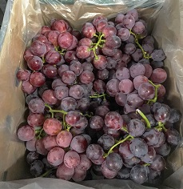“It is time for the leaders in the Department of Transport to step up and commit to doing what is right,” notes Werner van Rooyen.
“This process has dragged on for too long, about nine years already, and the fruit industry requires certainty. It is a very concerning situation to be in.”
He points to potential loss of income and job losses in the fruit sector caused by interruptions to exports. The employment-creating potential of, in particular, citrus, grape, banana, apples and pears, avocados and cherries, has, in fact, been formally recognised in the National Development Plan.
There is a fear that shipping lines will move their business to neighbouring ports like Walvis Bay (Namibia), Beira and Maputo (both Mozambique).
Confidence that extension will still be signed off
Werner says he is quietly confident that the Department of Transport will sign and publish the extension to the moratorium, a sentiment shared by Mike Walwyn.
“It would not only be in the best interest of the economy but also maintaining an acceptable level of trust between government and industry."
Werner adds: “We should also point out the hard work done up until now between government and industry and we would like to especially thank Advocate Johannes Makgatho from the Department of Transport for all his efforts.”
Publication date: Fri 10 Jan 2020
Author: Carolize Jansen
© FreshPlaza.com

