Fresh Plaza 30th May 2019

Seedless lemon brand launches in South Africa
The new LemonGold® brand, which follows in the footsteps of the globally successful ClemenGold mandarin brand, will launch in one of South Africa’s high-end retailers in June. Although seedless lemons are not new to the local or international agricultural market, previous South African consumer-facing offerings have not been backed by strong branding. Now consumers will be drawn to conveniently seedless lemons by a brand built on the same principles as ClemenGold, promising consistent quality, farmed according to Woolworths’ Farming for the Future standards and supported by a concerted marketing effort to build recognition and ultimate trust.
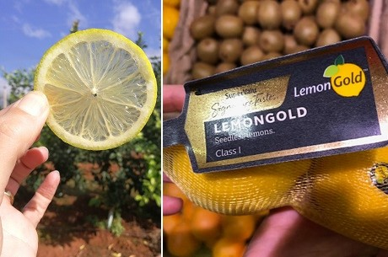
“In the current marketplace success for fresh produce growers does not only rely on good quality fruit or smooth logistics and especially not on low prices. It has increasingly more to do with strong branding backed by marketing excellence and the strength of the complete value chain supporting the process,” says Marius du Plessis, CEO of ANB Produce and Marketing, the commercialisation and marketing arm of South African based ANB Investments who also owns the ClemenGold brand. “Consumers increasingly base their trust and consequently their buying behaviour on reputation and visibility of brands. We are now ideally positioned to handle the distribution and marketing of this innovative brand.”
The brand has already found a sweet spot in the German and Irish markets at premium retailers where the seedlessness of the product addresses culinary frustrations experienced by chefs, home-cooks, health enthusiasts, mixologists and lovers of all things lemony. The seedless lemon has been described as the holy grail of the lemon industry. The global trend highlighting the health aspects of making lemons a part of daily life, has put the spotlight on this zesty fruit that brings flavour to almost any dish.
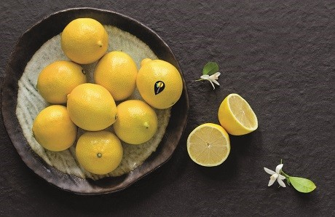
According to Marius du Plessis, delivering to retailers and the consumer at a consistently promised quality level in terms of taste and consumption attributes, remains important, but the equity of a visible and well-executed brand is a game changer. “ClemenGold has trail-blazed its path to sit proudly on the shelves of retailers such as Edeka in Germany, SuperValu in Ireland, Spinney’s in Dubai and various significant Chinese establishments, and our superior value proposition in conjunction with sound business sense from our export partners Core Fruit give us significant bargaining power. While the supply of our fruit is backed by marketing excellence and a major investment in a recognisable brand, we remain conscious of contributing to the sustainability of supply and retail partners. We call this our ecosystem where all parties contribute to and benefit from the growth.”
For more information:
Charlene Nieuwoudt
ANB Investments
Tel: +27 21 883 9723
Email: Charlene@abninvestments.co.za

