Fresh Plaza: 28th June 2018

Smaller fruit but exceptional quality

SA grapefruit: not a healthy market in Europe
South African grapefruit exports stand at 8.5 million 17kg cartons shipped by week 25, while initial reticence regarding the grapefruit season has given way to more positive sentiment. In the beginning colour development was slow and the fruit was small but of late, fruit have sized up.

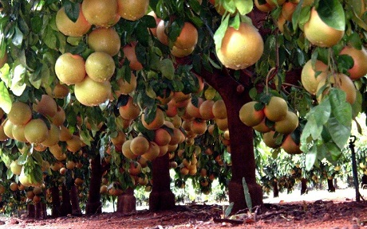

Last week the grapefruit estimate was upped to 15.7 million 17kg cartons, from 14.8 million 17kg cartons, as packouts have increasingly improved as a result of both colour and size distribution progressively improving. In the Letsitele area alone the estimate has been upped by 600,000 cartons.

“I don’t think there’s too much fruit. We’re back to a normal crop, with 60 to 65% already shipped and 70% packed,” says Rowan Vickery, head of citrus at Capespan South Africa. “We’re very lucky – the quality’s exceptional this year, with a long shelf life, and the South African industry has been approaching the marketing responsibly. There will be a pause in grapefruit packing of about four weeks, while most of the guys switch over to their early Valencias (they’re colouring up very nicely), and then going back to grapefruit towards the middle to end of July.”

This lull in grapefruit packing will allow fruit still hanging to further improve in terms of size.

“In every conversation with producers since the start of the season, sentiment has been turning more positive,” says Jan-Louis Pretorius, chairperson of the Citrus Growers' Association grapefruit focus group. “Initially a substantial percentage of the fruit was too small for export but fortunately grapefruit keeps on growing, which is why we have seen a consistent improvement in the size and packouts.”

Some producers say that, in some blocks, up to 30% of fruit has been too small for export and they have been struggling to fill up cartons. More fruit has been going to local juice factories, with fewer processing fruit exported due to caution around FCM and CBS.

Smaller fruit complicates marketing
“In general fruit was smaller than we expected which has already had a big impact on marketing,” says Piet Smit, managing director of Komati Fruit Group. “A lot of small fruit has already been exported, even some unpopular counts like count 60 for which there usually is no demand, which has caused some blockages in the European market, resulting in problems in terms of pricing and sales tempo. These unpopular, unwanted counts land in the hands of the traditional traders who, when the fruits don’t sell, lower the prices to move stock. It’s not a healthy market in Europe.”

Rowan Vickery adds that there is a lot of cheap local summer fruit on the European market as well as Spanish late navels and Valencias from Spain and Egypt, all jostling for space in the consumer basket.

“But some of the best grapefruit sales in the EU happen after the summer holiday, in September and October,” he notes.

The Far East – specifically China, Japan and South Korea – require large grapefruit for supermarket programmes and those markets have remained untouched by the preponderance of available small fruit.

“If you serve a wide distribution of markets and you’re not just dependent on European traders, you can have a good year,” Piet Smit says.

Pieter Vorster of Mahela Boerdery in Letsitele says that after a slow start regarding colouring, with small calibres, they are now peaking on size 50, followed by 45, 55 and 40. They market most of their grapefruit themselves, mainly to the European Union, also Russia (although prices there have dropped) and to the Far East.

“In the Far East, like China and Korea, South African grapefruit obtain good prices but the markets take low volumes. It’s an established market and we’d like to send more to the Far East.”

Grapefruit market development programme in South Korea
To that end, the Citrus Growers’ Association, in partnership with the Fresh Produce Exporters’ Forum and the economic section of the South African Embassy in Seoul, will be promoting South African grapefruit at 36 Emart stores, the largest retailer in South Korea, from 13 to 15 July.

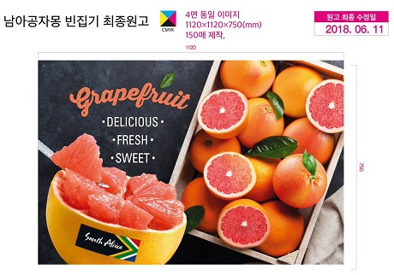

“South Korea is a very important, growing market for our grapefruit and through this generic promotion, which will be primarily focused on tasting sessions, we aim to position South African grapefruit as the equal of the Florida grapefruit with which they’re more familiar,” says Jan-Louis Pretorius.

An important component of this promotion, he notes, will be an analysis of the results. “Quantitatively we’ll measure the effect on sales but more important would be a qualitative analysis of consumers’ perceptions and usage behaviour because that's a better measure of sustainable growth. We want to heighten awareness of the quality differentiators of South African grapefruit. It’s well-known that South African grapefruit are externally better-looking than American grapefruit which have a lot of blemishes and marks, but their grapefruit is known for its high sugar and we want to show that we can be competitive in that respect too.”

For more information:
Jan-Louis Pretorius
CGA Grapefruit Variety Focus Group
Tel: +27 15 345 1782
Email: janlouis@groep91.co.za

Rowan Vickery
Capespan SA
Tel: +27 21 917 2600
Email: rowan_vickery@capespan.co.za
http://www.capespan.com/

Piet Smit
Komati Fruit Group
Tel: +27 031 007 0306
Email: piet@komatigroup.co.za
http://www.komatifruits.co.za/

Pieter Vorster
Mahela Boerdery
Tel: +27 15 345 1600
Email: Pieter@mahela.co.za
http://www.mahela.co.za

Publication date: 6/28/2018
Author: Carolize Jansen
Copyright: www.freshplaza.com

