Fresh Plaza – 24th April 2019

Almost time for South African citrus exports to resume
The South African citrus season is just around the corner and Summer Citrus from South Africa is preparing for the first shipments which are due to begin at the end of May. South African fruit is likely to become available in the US from early to mid-June. In terms of citrus varieties, easy peelers will be the first available, followed closely by Navel oranges.
"Summer Citrus from South Africa will be arriving in early to mid-June, perfect timing as the domestic season comes to a close," noted Suhanra Conradie, CEO of Summer Citrus from South Africa. Easy peelers will be available end of May and early June. Navels will follow starting towards the end of June and we anticipate healthy supply through the end of the season. Cara Cara oranges, while in short supply, will be available throughout the summer months. Star Ruby is a later summer fruit and should start to arrive by the end of June and will last through the end of September."
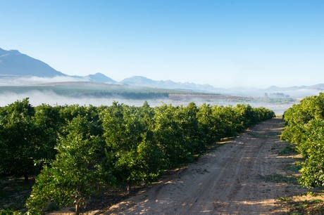
More focus on marketing efforts this year
This year's focus will be to fuel greater demand for citrus during the summer months. Summer Citrus from South Africa said it is currently looking to retailers and work with them to help promote South African citrus. Conradie also noted that there will be good promotable volumes.
"Summer Citrus from South Africa, including Navels to easy-peelers, will be broadly available and can be procured from any one of our valued importers," she said. "Our Association’s importers are ready to work with retailers on stronger marketing activations to help elevate demand and sales for South African fruit throughout the season."
Celebrating 20 years at Viva Fresh
This year, Summer Citrus from South Africa is celebrating 20 years of providing fresh citrus to the U.S. market. The celebrations will be a focal point at this week's Viva Fresh Expo in San Antonio. A champagne toast will be held at the company's booth to mark the occasion.
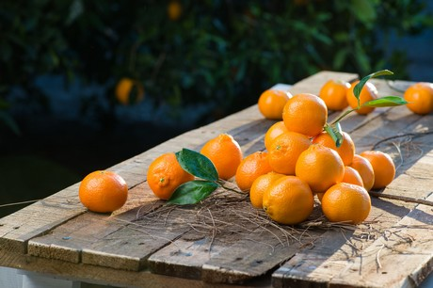
"Showing and expressing our gratitude to 20 years of successful collaboration and support of the fresh produce industry is our main objective in attending and supporting Viva Fresh," Conradie shared. "We are happy to sponsor Friday’s Keynote Luncheon and invite everyone to our booth on Saturday at 2:30 pm at the Expo prior to happy hour for a champagne toast."
She added that the show is also an excellent opportunity to connect with attendees and discuss the upcoming South African citrus program. "Viva Fresh provides the industry with a great opportunity to network and discuss the busy summer sales season in culture-rich San Antonio while coming together under one roof during the conference and expo. The show provides our association and our importers with an excellent place to show our support for the industry and meet face to face with our customers."
Summer Citrus from South Africa will be at Booth #34.
For more information:
Suhanra Conradie
Summer Citrus from South Africa
Ph: +1 (856) 379-0026
suhanra@summercitrus.com
www.summercitrus.com

Publication date: 4/24/2019
Author: Dennis Rettke
© FreshPlaza.com

