Fresh Plaza – 19th June 2018

Fort Beaufort, Eastern Cape: “This packhouse is a beacon in this area.”

Eden Agri Citrus: black farmers assume majority share-holding in packhouse
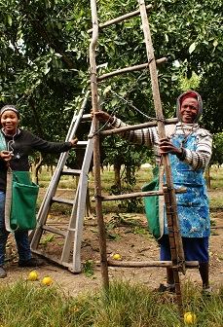
In February this year the fortunes of a number of black citrus farmers changed for the better with the formation of Eden Agri Citrus, a holding company that now holds the majority of shares in the Eden Agri Services citrus packhouse outside Fort Beaufort.

Eric Nohamba, who has been farming citrus for 26 years, is the chairperson of Eden Agri Services. Siseko Maqoma, director, says: “From the outset Shaun Brown, who was sole owner since the packhouse became operational in 2010, had a vision that we should all take ownership of the packhouse, but unfortunately when we started out none of us had capital to be part of the shareholding. We’ve gone to the stage now where five black farmers have taken up 70% of the shareholding of Eden Agri Services.”

Eden Agri Services are now made up of ten growers who deliver their product to the packhouse, which is packing clementines and navels at the moment. Approximately 75% of the fruit packed here are destined for the export market. (The packhouse can also pack avocados, which do well in this area, and would fit in nicely after the end of the citrus season in September.)

The packhouse has recently unveiled its new four lane-packline with optic sorter and has the capacity to double its current operations. All of their citrus is marketed by Port Elizabeth-based Safpro.

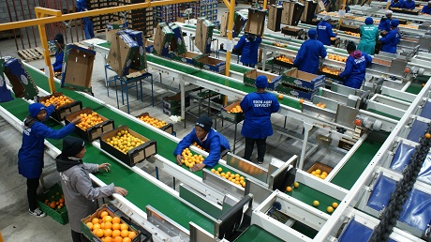
Eden Agri Services packhouse outside Fort Beaufort

“We’re really trying to help each other out and look out for each other. All of the Satsumas in our group are on Shaun’s farm so when the Satsuma season starts, we take our teams and help with the picking.”

“Historically this is a very impoverished area and this packhouse is a beacon,” Siseko (a direct descendant of the famous Xhosa king Maqoma who, like Nelson Mandela, was sent to Robben Island, for his opposition to British rule) continues. “If you take out our production units and the packhouse, there’s not much left.”

For this reason Eden Agri Citrus has started talking to investors about involving the surrounding rural communities and developing communal land along the Kat River catchment area for citrus production for export, for which they will provide the technical expertise.

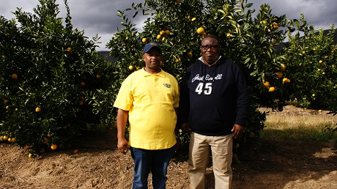
Siseko Maqoma and Eric Nohamba on Siseko's farm, Gonzana Farm

Title deed transfers at a glacial pace
Eric Nohamba, Siseko Maqoma and their colleagues have had cause to prove their tenacious dedication to farming – they are beneficiaries of a privatisation scheme started almost 30 years ago by parastatal Ulimoco in the erstwhile (and ostensibly independent) ‘homeland’ of Ciskei, that was meant to transfer economically viable farming units to black farmers.

The project was supplemented by training courses offered by Israeli experts in citrus and livestock farming, some beneficiaries even visiting Israeli and Florida citrus orchards, but the actual transfer of title deeds to beneficiaries is, all these years later, still unfinished business.

Neither Eric nor Siseko is the official owner of the farms they have been working for a quarter of a century or longer. This of course has a major impact on their ability to generate production capital and their ability to expand their production into what this area is best known for: soft citrus. Both their farms are still mainly planted with navels, which means a compacted harvesting window.

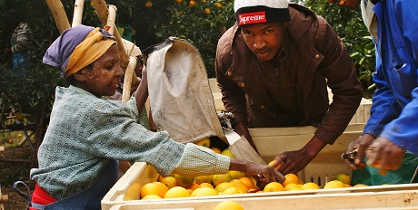
Picking navels on Gonzana Farm near Blinkwater, Eastern Cape

After dozens of meetings with government officials, there still isn’t a tangible reason for the interminable delays, says Eric. “If you ask them, they blame the change-over in staff or documents that got lost. But some of the black farmers coming out of the original scheme have been successful in getting their title deeds.” Have they ever considered giving up, given the obstacles? “We’re passionate about farming,” Eric simply answers.

“Through all of our trials and tribulations, at the end of the day the message is very positive: we’re moving forwards, perhaps not at the rate we’d like to, due to these challenges,” Siseko says. “I think the worst is over, primarily due to finding this home which is a fillip for us, an open, transparent family type structure.”

“Shaun really has gone out on a limb for us,” he adds.

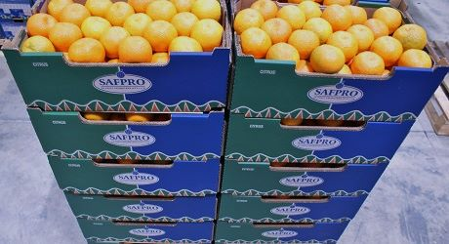
Safpro in Port Elizabeth markets the citrus of Eden Agri Services

For more information:
Shaun Brown
Eden Agri Services
Tel: +27 46 645 1450
Email: shaun@edenagri.co.za
Publication date: 6/19/2018
Author: Carolize Jansen
Copyright: www.freshplaza.com

