Fresh Plaza Article – 7th August 2018

South Africa welcomes removal of citrus from high risk-list
South Africa has welcomed the outcome of a meeting of the European Commission’s Committee on Plant Health in the week of 9 and 10 July 2018. During this meeting the proposal of eight EU member states (among them France and Spain) to introduce a category of high risk plants and products (which included citrus) under article 42 of the new plant health regime, was rejected. The new plant health regulations will come into effect by the end of 2019.

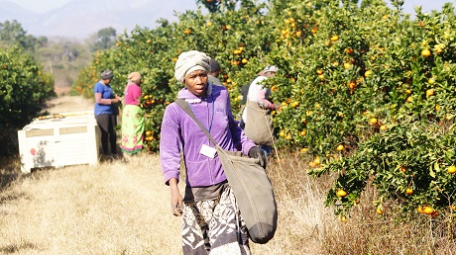

Up until now the EU has set a principle of a ‘soft border’ which means a product is acceptable for import until proven to pose an unacceptable risk. The proposal submitted by France on behalf of Mediterranean countries would set a ‘hard border’, which means access is denied a product until proven it poses no risk, by placing constraints on certain categories of the incoming fruit trade. According to their proposal, commodities like citrus would as a matter of course be subject to the regulatory measures called upon during a moment of crisis, like the detection of Asian greening disease or HLB.

This would, in terms of the World Trade Organisation, impose a measure inconsistent with the risk posed by the likes of citrus black spot. Not surprising, then, that Northern European member states have opposed the list of eleven products, which was later reduced to eight (excluding citrus) and is now left with a single item.

The Southern grouping frames this rejection and decision, driven by Northern member states, as a lack of solidarity within the European Union, while within the South African citrus industry proposals such as the one submitted by France and Spain, are widely regarded as protectionism.

"We had high hopes for this new proposal," commented the president of Valencian Association of Agricultural Producers (AVA-ASAJA) Cristóbal Aguado after the outcome of the committee meeting, "and unfortunately, [we] have been frustrated, once again, by the lack of solidarity of the northern countries. We find it unacceptable for the maximum level of protection not to be granted to a product such as citrus, which is besieged and threatened by diseases such as Black spot, which has been detected in citrus shipments imported from South Africa, or Greening, to name just two."

In 2013 he had called for the immediate closure of borders until such time as “South Africa is capable of guaranteeing the export of citrus with adequate plant health.”

CBS interceptions stand at zero
Currently, CBS interceptions on South African citrus destined for Europe stand at zero for the 2017/18 season. The South African position is that CBS is not a quarantine disease and has never established itself during decades of South African citrus traded in Europe. Recently South Africa’s stance was bolstered by the US decision that citrus from South Africa’s CBS areas can in the near future be sent there, provided it is subjected to an import rule.

“We’re very happy and obviously we worked extremely hard beforehand to stop the proposal by providing scientific data on these products to EU member states," says Deon Joubert, South African Citrus Growers’ Association’s envoy for market access and the EU. “Our viewpoint is that it’s not in the best interests of a fair and liberalizing world trade. Every affected market will react in turn and it will frustrate trade and ultimately economic growth. The world is already tinkering on the verge of undoing all the benefits of liberating agricultural trade in the late 1990s."

“Within two years the CBS issue should be put to bed,” opines a South African citrus industry expert and farmer. “It’s a political issue.”

Publication date: 8/7/2018
Author: Carolize Jansen
Copyright: www.freshplaza.com

