Fresh Plaza – 23rd March 2018.

Heavy and welcome rain over central South Africa disrupts harvesting
Heavy and sustained rain over central and eastern South Africa is alleviating a dry summer for many areas, where the annual summer rainfall is still under par. Close to 150mm fell over 24 hours in central Pretoria.

However, the soft rain (with thankfully no hail) has been disrupting fruit, vegetable, grain and macadamia harvesting in some areas and creating pathogen pressure and possible postharvest quality issues but, as one producer notes: "Cape farmers would probably love to have these problems."

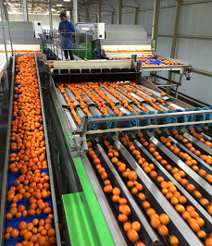
Rain’s effect on the citrus harvest
The harvest of soft citrus like Satsumas has started in areas like Burgersfort and Senwes but harvesting is suspended while it is still raining. Satsumas are very water-sensitive and there is the possibility of ballooning fruit. By next week it should become clear whether Satsumas have been affected by the rain.

Not all Senwes producers have started their harvest yet. The cool temperatures which have accompanied the rain come at a great time for the colouring of fruit. Size will benefit from the rain, which fell in copious amounts in the catchment area of the Loskop Dam to the east in the Highveld.

In the northeast of the country, Letsitele is still very dry, with below average rainfall thus far. Since 1 July 2017 only between 200 and 250mm have been measured and dam levels are on the low side, but today it’s raining softly there. The first navels, all destined for the local market, are coming in from there. Rain will be a boon for the sizing on Valencias, whose harvest is still at least a month away.

Hoedspruit has seen substantial rain and so has its water catchment area around Graskop so that the Blyderivierpoort Dam now stands at 75%. The lemon harvest around Hoedspruit is also on hold because of the rain.

