Fresh Plaza – 23 October 2019

World Citrus Organization launched at Fruit Attraction

The newly founded World Citrus Organization (WCO) was officially launched at Fruit Attraction, Madrid. With this official presentation, citrus fruits are finally placed at the same level of coordination worldwide as other fruit categories, such as pears & apples, kiwis, avocado or red fruits, which already have their own global platforms.
The WCO will act as the global platform for dialogue and action between the citrus producing countries worldwide. The core aim of the WCO is to facilitate member countries to better face common challenges and seize opportunities for the collective benefit of the citrus sector, in a spirit of cooperation and transparency.
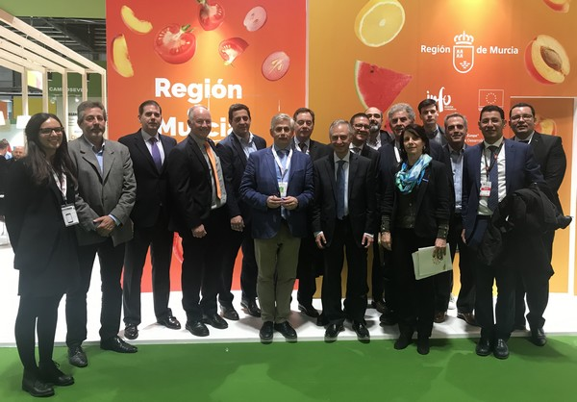
Led by AILIMPO and the Citrus Growers’ Association of Southern Africa (CGA), sector representatives from Argentina, Chile, Italy, Morocco, Peru, Spain, and South Africa decided to join forces to create a global citrus platform. Other countries that were unable to attend the meeting have also committed to the project, and the remaining global producers are invited to join the organization.
The primary objective of the WCO is to facilitate collective action in the sector. Most recently the sector has been faced with an array of issues including growth in production, overlapping of seasons, changing climate conditions resulting in varied quality and biosecurity challenges, increased competition within the citrus category and between other fruit categories and food products as well as stagnating fruit consumption.
Specifically, the WCO’s mission is to:
- Discuss common issues affecting citrus producing countries.
- Exchange information on production and market trends to prepare for the next decade to come.
- Foster dialogue on policy issues of common concern.
- Identify and promote Research and Innovation projects specific to the citrus sector.
- Liaise with public and private stakeholders on citrus-related matters to highlight the importance of citrus
producers and the need for a fair return.
- Promote the global consumption of citrus.
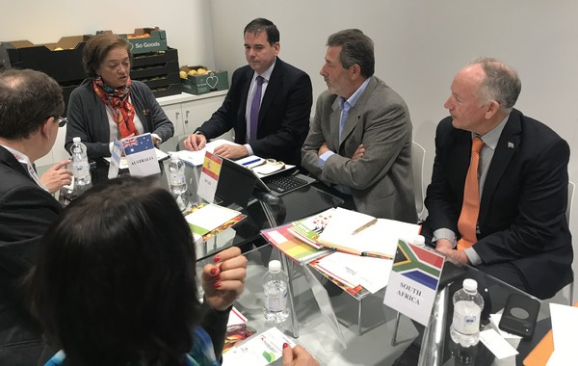
During the official presentation in Madrid, the Director General of Agricultural Production and Markets of the Spanish Ministry of Agriculture, Esperanza Orellana, emphasized the importance for Spain, leader in the production and export of citrus fruits, to be at the forefront of this project. The Counsellor of the Region of Murcia, Antonio Luengo, said that, leaving aside the competitive factor, it is essential to share information and experiences for the collective benefit of the sector, which is of key strategic importance for Murcia and for Spain.
With South African citrus exports due to increase by 25% in the next five years, and similar expansion expected by other citrus-producing countries, this organization will put citrus fruit in its rightful place in the consumer’s mind – as a nutritious, healthy option. Stimulating demand will help to grow the category and claw back some market share lost to other fruit sectors.
Freshfel Europe, the European Fresh Produce Association will coordinate and administer the WCO. The next meeting, where the formalities for the foundation and future structure of the organisation will be formalized, will take place at Fruit Logistica 2020 in Berlin.
For more information:
Freshfel Europe
Tel: +3227771580
Email: info@freshfel.org
www.freshfel.org
Publication date: Wed, 23 Oct 2019

