South African citrus hopes for a 2021 debut in the Philippines
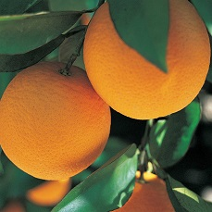
Justin Chadwick, CEO of the Citrus Growers Association. notes that it has taken "great patience" to finally get to the point of official access for South African citrus to the Philippines, with its population of more than 106 million people.
Currently annual Philippine citrus imports of around 80,000 tonnes of citrus are dominated by China while the largest Southern Hemisphere exporters of citrus to the Philippines are Argentina and Australia.
The Philippines' Bureau of Plant Industry has signed the work plan, the final step in granting South Africa access for its citrus. It is the product of yearly visits and much lobbying work by South Africa's fruit industry, he says in his weekly newsletter. The protocol was eleven years in the making.
Chinese mandarins and oranges are dominant in their citrus market, as well as Pakistani soft citrus and Australian and US oranges.
Most lemons imported by the Philippines come from the USA and China; the latter is also the source of their grapefruit.
Reshipments of oranges, mandarins and lemons from Hong Kong fill out their citrus supply.
Publication date: Mon 7 Sep 2020
Author: Carolize Jansen
© FreshPlaza.com

