Fresh Plaza –

Andries du Preez, San Miguel South Africa

“I think it will be a good lemon season for South Africa”
In the Sundays River Valley, San Miguel is about a third of the way through a lemon harvest which was delayed by some weeks due to slow colouring. While lemons have been late, Eastern Cape navels have been early, placing pressure on packhouses. At San Miguel South Africa, Cara Cara navels ended last week and the Nadorcott harvest starts this week.
The lemon crop is peaking at good sizes – 100, 113 – and they’re quite happy with the quality, says Andries du Preez, San Miguel country manager. It’s a commodity in which they’re strong, up to 35% of their total citrus portfolio in South Africa.
Their current citrus exports from South Africa run to 70,000 tonnes per year, with a value of about US$55 million.
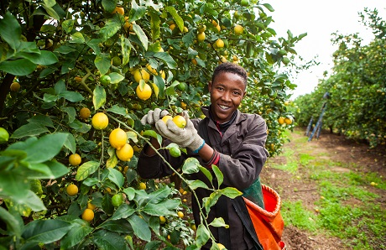Photos: San Miguel South Africa
Strong demand from Europe for lemons
“We’re seeing strong demand for lemons from Europe. That’s still a good market for us, perhaps more of a focus for us than for other exporters because of San Miguel’s strong links with Europe and specifically the area around the Mediterranean Sea. Europe still receives about 40% of our exports. We focus on supermarkets, in the EU and the UK, as well as in the Middle East and Canada.”
San Miguel’s lemons also come from Argentina and Uruguay, two countries with which the South African season overlaps. Argentina is exporting less this season, because of pressure on quality due to rain. “I think this will be a good season for South African lemons in Europe.”
Processing grade lemons are sent to Venco Fruit Processors in which San Miguel is a shareholder, a facility in Addo where lemon products like citrus oil, juice and aromas are extracted. “Processing makes up 15 to 20% of our lemon business in South Africa and it’s a good line, pretty competitive in its returns at the moment. It really helps to have a variety of markets, for instance in a year with a high incidence of wind damage and mealybug pressure like this year. We also export processing grade fruit to the United Kingdom.”
Clients in France receive chemfree lemons from San Miguel South Africa.
San Miguel South Africa gets its earliest citrus volumes from grower partners in the north of the country, for instance Valencias for Europe starting this week and grapefruit (not large volumes), for which Europe’s looking promising at the moment, he says.
San Miguel expands on late navels
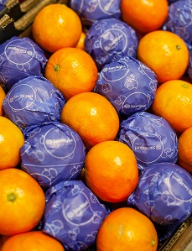Regarding China, Andries notes he’s a bit worried about the volume of oranges that have been loaded for that market already, but, he notes, prices are holding for the moment. They avoid the Chinese wholesale market as far they can, opting for retailers and other strategic markets.
As for the drop in South African navel volumes (from northern production areas), he doesn’t foresee that its impact on exports will be particularly significant. The local orange market has been very strong and besides, Spain and Egypt’s presence looms ever larger on the global orange market.
“It definitely is a cause of concern for us. Egypt is tremendously competitive on costs, and every year the overlap between their late varieties and our early varieties, and the other way around, becomes stronger. That’s why a company’s portfolio of cultivars is so critical.”
To that effect San Miguel, like many other South African citrus producers, are every year removing some early navel orchards and replacing it either with lucrative late navels like Cambria and Witkrans, both South African cultivars with characteristics particularly sought by the Chinese market (like a firm skin), or lemons or, of course, soft citrus.
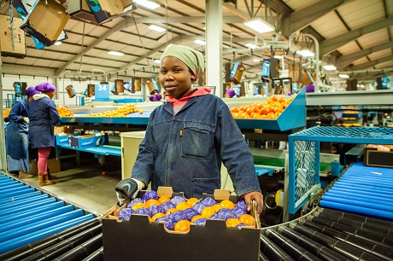
First Chinese Nadorcott campaign in alliance with ClemenGold
It is their first season to take off soft citrus grown under nets, and they’re very happy with the results, Andries says. Sunburn and the ubiquitous wind damage of this season has been much reduced. In the Sundays River Valley they don’t yet have many hectares under net, approximately 70ha out of 1,050ha. (They took a catholic approach in their netting trials, covering samples of all orchards, even early navels, to observe the effects.)
Their clementines and Novas have been packed, now their attention turns to Nadorcotts and Orris. For the first time time, San Miguel is marketing the large counts of their Nadorcotts in alliance with ClemenGold in China this season. Smaller counts will go to the UK, the EU and Canada.
The United States’ soft citrus market is serviced by San Miguel’s Peruvian and Uruguyan production.
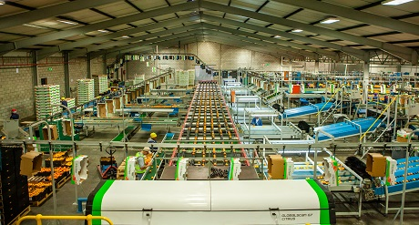San Miguel's packhouse in the Sundays River Valley
Port problems necessitate careful planning & extra costs
“Our biggest challenge is the problems at the port,” he concludes. “We’ve moved substantial volumes from Port Elizabeth to Durban and Cape Town. The situation is still manageable, although it requires extra costs and careful coordination to continue servicing our clients, and we’re fortunately still able to get all of our shipments out.”
The Argentine company’s South African filial owns two packhouses in the Sundays River Valley, where it has been acquiring production units for much of the past decade, and packs its Gamtoos citrus at a packhouse in Patensie.
The company has recently set up the Thudana Citrus Company to give 120 farmworkers a 30% stake in a complete citrus operation in the Sundays River Valley, worth R200 million (12.5 million euros), along with training and development programmes for beneficiaries, an initiative the company places within the context of economic justice, given South Africa’s past.
While San Miguel is involved in the avocado and table grape sectors in Peru, the company has no such strategy for South Africa, which remains solely a citrus player in their fold.
For more information:
Andries du Preez
San Miguel South Africa
Tel: +27 41 368 9015
Email: adupreez@sanmiguelglobal.com
http://sanmiguelglobal.com/en
Publication date: 7/10/2019
Author: Carolize Jansen
© FreshPlaza.com

