Fresh Plaza -25th May

"South African citrus exports to China remain strong"
Every year, South Africa exports large volumes of citrus fruits to China. The Chinese market is an important export market for South Africa and the export volume to this market is growing every year. The export season for lemons and grapefruit started a while ago and these will be joined by tangerines, oranges, and mandarins in the next few months.
Berda Fruit is a South African company specialized in the plantation and export of citrus fruit. The company has more than 20 years of experience in the industry. Mr. Zhang Jie, a spokesperson for Berda Fruit, recently analyzed current conditions in the citrus fruit export market:
"The South African citrus season started several months ago. The first shipping container of lemons arrived in Guangzhou Market on the 29th of February, while the first shipping container of grapefruit entered Guangzhou Market on the 13th of April. In addition, the South African Nova tangerine entered Jiangnan Market only two days ago. The overall production volume in South Africa expanded this year. The export volume also increased, although not at the same pace for all citrus fruits. The soft-peel mandarin shows less growth than other citrus fruits, while oranges, grapefruits, and lemons are all doing very well this year."
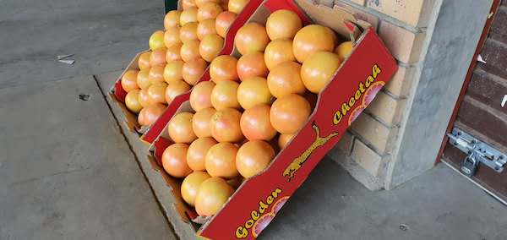
European market demand for South African citrus fruit is extremely strong. South Africa exported a much larger volume of citrus fruits in the last two months in comparison with the same period last year. The main reason for this growth is the fact that citrus fruit contains a lot of vitamin C, which is beneficial for people's health. Vitamin C strengthens the immune system. And people have started to pay more attention to their immune system since the outbreak of Covid-19. This is reflected in growing sales.
"European market demand for South African lemons has significantly increased. In China, however, market conditions for imported lemons and oranges are not that great, because the domestic production season of lemons and oranges is not yet finished. Furthermore, considering the impact of the Covid-19 pandemic, importers are extremely cautious at the moment. The import volume is not likely to grow much in the near future. And the price is likely to remain relatively low in comparison with the same period last year."

As Mr. Zhang Jie pointed out, the market conditions are much more difficult to control this year. South Africa implemented quarantine measures in response to the Covid-19 pandemic and distribution from orchards became much more difficult. However, South African export continued relatively undisturbed, which brought fruit traders in South Africa some relief.
"Judging from the arrival of products, the Covid-19 pandemic barely had any impact on transport. We still have shipping containers arriving in ports across the globe every day. Furthermore, the quarantine measures are now being slowly relaxed. We export the highest-quality oranges to China, because the Chinese market has a strong demand for top-quality imported fruit. We will continue to export even more oranges and grapefruit to China in the next few months."
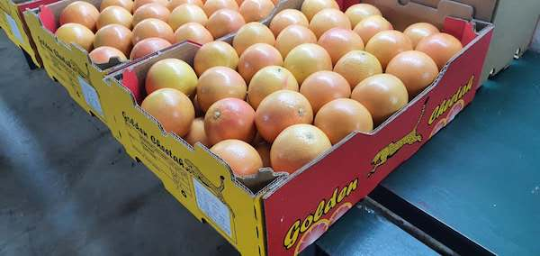
Publication date: Mon 25 May 2020
© FreshPlaza.com

