Fresh Plaza – July 2019

Major production region drops export estimate by 25%, but fresh varieties from other strong regions coming on-stream

South African navel crop down by 2.5 million cartons
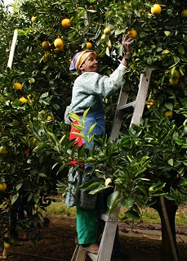Across the country the navel harvest has had a slow start and the industry is seeing bigger fruit (up to 60% of count 64 and larger) and a smaller crop. A poor start to the navel season could have a ripple effect on Valencias.
The navel export estimate from the start of the season has been revised downwards by 2.4 million cartons, from 26.8 million to 24.5 million 15kg equivalent cartons on navels and also a downward adjustment on Valencias, 51.8 million cartons from an original 52.8 million cartons.
In the Senwes production region (Marble Hall/Groblersdal), where last year they took off their highest ever navel crop of 8.9 million export cartons (making it the dominant navel region in South Africa) this year sees a 30% drop on 2018’s volumes and a 25% drop on the original export estimate of 8 million cartons.
However, in the provinces of the Eastern Cape and Western Cape (both roughly equivalent in production to the Senwes area) the navel situation looks quite different: the harvesting of late navels like Cambrias and Autumn Gold are due to start in two to three weeks, colouring is good.
“Buyers should know that they can come to us for good quality as we are entering fresh varieties,” says a citrus producer from Citrusdal in the Western Cape. “I feel the decrease of 2.5 million cartons from the Senwes area creates an opportunity for other regions this season.”
In the Eastern Cape’s Sundays River Valley, the slow start due to colouring will be offset by more late navels.
Senwes: hail, wind and slow colouring
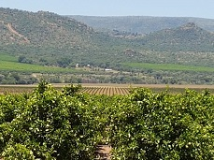Their early navel season has been a very difficult one: some producers have not been able to export a single carton of early navels from some blocks.
The area has now started on its late navels like Rustenburg and Cambria navels, as well as with Turkey Valencias (Midknights are expected to follow in about two weeks’ time in this area).
Producers consider last year’s bumper crop to have tapped the orchards’ energy to an extent that was initially underestimated, as was the effect of the sporadic hail occurring throughout the summer period (some blocks being hit up to five times during the single season; very few early navel orchards are covered by hail netting).
Wind damage has also eroded packouts on some farms, but hail has inflicted the most damage. Colour development was late, which resulted in low acid levels by the time of optimal colour, while large fruit have presented problems with granulation. As a result Senwes producers have opted for the local market and juicing as alternatives to export.
“No use creating unrealistic expectations of navel harvest"
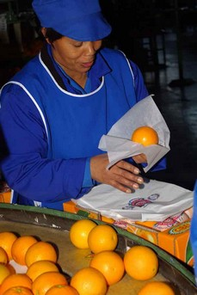“It’s a big knock,” says a producer in the area, noting that it could create opportunity for orange producers elsewhere in the country.
In the Eastern and Western Cape producers are approaching their peak navel season after a similar slow start due to colour development, with widespread reports of wind marks.
When a producer is faced with a block of early navels with packouts of 15 or 20%, some make the choice to let the fruit hang, colour up on the tree and sell on the domestic market.
The late navel crop in Senwes is looking better but all of the producers to whom FreshPlaza has spoken reiterate that it’s important that the market understands that the volumes of late navels – whose quality is in general superior to early and mid-season navels, and this year is no exception – is expected to be down to the same extent as early and mid-season navels.
“It’s no use creating unrealistic expectations regarding the volumes of navels from South Africa this season,” a Senwes citrus producer cautions.
Risk of oversupply to China
An empty market in China has been pulling strong navel volumes, which could result in an oversupply which is a concern, particularly in light of a reported half a million cartons of Egyptian Valencias recently sent to China. Due to slow colouring, some yellow fruit from South Africa has ended up in China, where it faces competition from well-coloured Australian navels. One producer notes that the widely planted Palmer navel is inherently too yellow for that market.
There are fears of a bottleneck of supply forming in China which could hurt marginal product that doesn’t fully meet market requirements.
There seems to be a general move away from the Middle East driven by the season’s larger sizing, although some producers notice a growing appreciation of the fact that late navel varieties are a premium product and prices are fair on specific counts like 72s and 88s.
Then there are the lacklustre Russian and European markets where there are still Egyptian and (in the latter) Spanish fruit available. The current heatwave is also slowing down the sales tempo on oranges.
The Egyptian orange crop is increasing and their Valencias remain longer in the market than in the past, while their location gives them a big advantage regarding transit times and logistical costs.
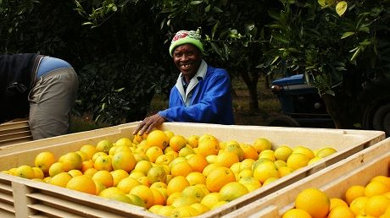
US navel campaign later than 2018
Navel shipping to the USA is lagging behind last year, not a bad thing given the Californian fruit still to be absorbed and last year’s poor returns on navels, and should get underway in the second week of July.
Navels are already being squeezed for shelf space by soft citrus and there is an expectation that Valencias could start feeling the same pressure in the coming years.
The profitability margins on navels (especially early navels) are amongst the lowest in the citrus industry.

Publication date: 7/1/2019
Author: Carolize Jansen
© FreshPlaza.com

