Fresh Plaza – 1st June 2018

Average rainfall of 100mm for month of May across south western Cape

“It feels like a real Cape winter again”
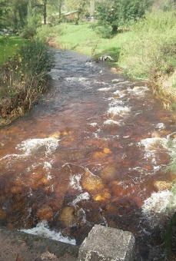
Much of South Africa is wet and cold, with snow falling in Lesotho, counter seasonal rain over the central regions and in the Western Cape the mood is exuberant.

Winter rainfall in the Cape has started in earnest with an average of 100mm for the month of May across the south western parts of the province. Late last night and early morning heavy rain fell over the Western Cape, causing flooding in some parts of Cape Town.

“For the first time in three years it feels like a proper Cape winter – cold and misty and rainy,” says a farmer in Paarl. In some areas waterfalls are running that have been dry during the past three winters.

According to South African Weather Bureau figures, over the past 10 days up to 166mm have been recorded in Ceres, 89mm in Grabouw, 102mm in Paarl, 95mm in Wellington and 211mm over Kirstenbosch Botanical Gardens in Cape Town!

Up towards the West Coast rain has been lighter – 12.5mm reported in Piketberg, about 10mm in Trawal – but farmers there aren’t unduly worried. “What we’re looking at is rain in the catchment areas to fill up the dams.”

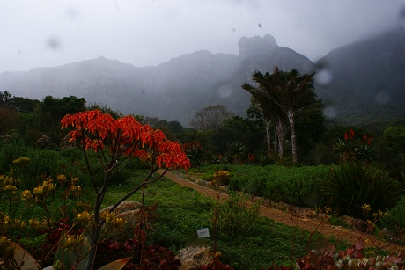
Kirstenbosch Botanical Gardens which received 72mm over the past 24 hours

The Theewaterskloof Dam is still at a low 14.7%, an improvement of almost 3% as a result of the previous rains. The rain of last night should reflect in the latest dam levels, made public on Monday. The soil is generally quite saturated and there’s a lot of runoff, says Dudley Rowswell, meteorologist. “Tomorrow there will be some ‘clearing’ showers and then the next rain is scheduled for next weekend.”

It is still too early in the season for snow over the mountains of the Boland which is equally vital for healthy water levels.

“The rain has picked up our spirits,” says a grape farmer in Olifantsrivier area. “The winter has started in the right way.”

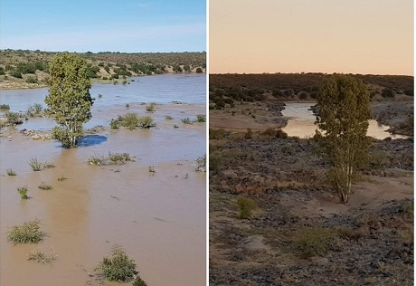
A comparison of the Orange River near Hopetown, Northern Cape, after recent rain (Photo: Frida van den Berg)

Publication date: 6/1/2018
Author: Carolize Jansen
Copyright: www.freshplaza.com

