Fresh Plaza – PPECB report – 3rd July.

Lucien Jansen - Perishable Products Export Control Board

South Africa's export inspection agency refutes claim of service suspension
The Perishable Products Export Control Board has confirmed that no inspections or checks of any kind have been suspended this year for any reason whatsoever, despite a claim made to this effect in the article 'Lots of space for overseas citrus on European market' published on FreshPlaza yesterday.
"All inspections including Citrus Black Spot and False Codling Moth were conducted as per requirements with good cooperation between all parties. To date, no interceptions for regulated pests have been reported from the EU," says Lucien Jansen, CEO of the PPECB.
He notes that the coronavirus pandemic certainly has had an impact on PPECB resources, as with all service providers within the supply chain. "The PPECB is, however, in a very fortunate position to be able to rely on a pool of fully trained contract staff. This pool of resources is used to supplement permanent staff, especially during peak seasons. This year was therefore no different."
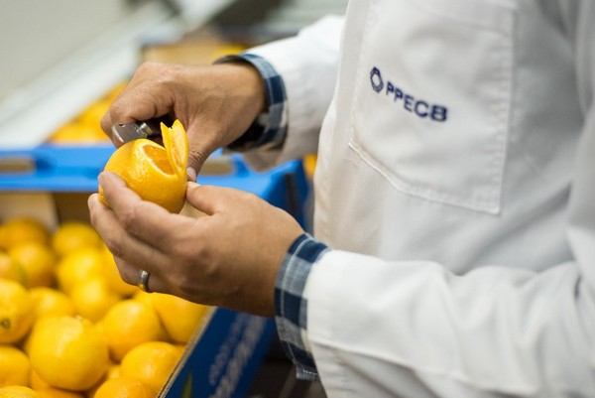
Favourable citrus market conditions
Citrus exports have taken advantage of favourable market conditions and it appears that the demand for Vitamin C enriched fruit has increased, especially during the current circumstances.
From January to June this year 247,282 citrus pallets have been inspected and shipped to the European continent, compared to 171,704 citrus pallets last year and 209,291 during the same period in 2018.
"The PPECB remains committed to supporting the perishable produce industry with the objective to enhance of South African exports whilst ensuring compliance with relevant legislation and export requirements. We therefore continuously scan the environment and engage with stakeholders to maintain effective and efficient levels of service," he concludes.
For more information:
Perishable Products Export Control Board
Tel: +27 21 930 1134
Email: info@ppecb.com
https://ppecb.com/
Publication date: Fri 3 Jul 2020
Author: Carolize Jansen
© FreshPlaza.com

