Fresh Plaza – 22 August 2018

Transport and harbour facilities under huge strain during the height of the season

Epicentre of soft citrus boom
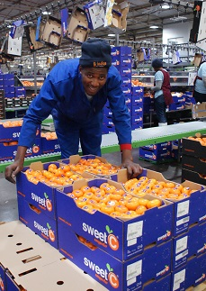
One of the largest soft citrus packhouses in South Africa is situated in Burgersfort, Mpumalanga, an area that has two things going for it: some of the best soil in the country, a Hutton that continues down for many metres, and a climate of cool nights and hot days, eminently suitable to soft citrus production.

Put the two together with the global boom in soft citrus, and you have the recipe for exponential growth, to which Indigo fruit Farming has responded with its Naranja packhouse of 14,000m² and the capacity for 100 bins (or around 38 tonnes) an hour.

Some navels and Valencias, and an eventual portion of 10% of lemons are packed here, but mostly it’s soft citrus that are delicately lowered onto the Maf Roda sorting line. The packhouse has received the highest accreditation ratings of both the British Retail Consortium Accreditation and Tesco.

“We treat soft citrus like stonefruit, a very sensitive commodity,” says Josef Malan, general manager of Naranja Packers. “The difference between a class 1 and a class 2 carton is R100 [6 euros]. In a modern packhouse we have complete consistency – class 1, class 2 and select are always the same. With modern technology you can get a 2% to 10% improvement in packouts – it’s had a dramatic influence.” Lucille Strecker, systems and information manager at Naranja, notes that traditionally, class 3 fruit accounted for up to 15% in the packouts, but that average is now down to 8%.

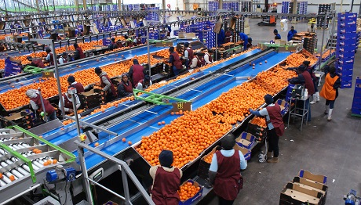

In designing the upgrade of the original packhouse, Josef Malan and his colleagues had visited packhouses worldwide, with the view of including pioneering automation so that, if ever need be, the packhouse can keep running with 18 people. Besides, as he points out, to process 100 bins per hour would necessitate twice their current staff numbers.

As it is, now during high season there are just over 400 people working day and night to sort and pack the bins of soft citrus coming in from a radius of 200km: Letsitele, Hoedspruit, Burgersfort, Nelspruit. Their projections are for 64,000 tonnes a season and currently it stands at approximately 30,000 tonnes, a stepdown from where they expected to be this year after hail in the Lowveld reduced it by 8,000t.

In the quest to differentiate themselves and their product – ClemenGold and SweetC mandarins are their biggest output – the packhouse offers over twenty different packaging formats to clients, a process which took five years to source the right carton designs, the right materials and the right machinery.

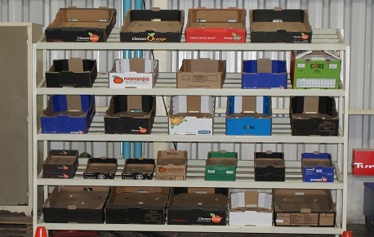
The range of packaging formats packed here

Another first was their biological water recycling plant. It filters and cleanses the 50,000 litres of water used in the packhouse for re-use in irrigation.

Tremendous pressure on road and harbour infrastructure
Getting the fruit from the packhouse and to the foreign buyers is a concern, as road infrastructure (rail infrastructure plays a scant role in fresh produce transport) and harbour facilities are groaning under the weight of the tremendous increase in citrus and other fresh commodities.
“Our challenge ahead is transport and logistics,” says Josef Malan. “Say you pack 32 pallets an hour and the packhouse is working through the night, that’s 640 pallets per day and to move that, you’re talking approximately 30 trucks. So you need 30 trucks at the packhouse, 30 on the road and another 30 on their way back, in other words 90 trucks in circulation for one packhouse.”

That is, assuming that everything goes well at the harbour. A recent strike of harbour workers caused a delay, as do mundane things like insufficient reefer plug points at the harbour or long queues of trucks at the harbour. “The trucks back up into the surrounding roads and traffic officials are forever writing out tickets for our truck drivers,“ Lucille says. “At the harbour the trucks can’t offload quickly enough. They stand and wait if there aren’t enough cool rooms available.”

The height of the avocado season coincides with that of citrus, which places further strain on cool facilities at the harbours. The choice of harbour for Naranja Packers depends on cultivar, timing and destination. If fruit go to Cape Town Harbour, almost double the trucking cost from Burgersfort, it’s in the European market a week earlier, while Durban Harbour provides good opportunities for return journey freight (although the recent listeriosis scare affected that).

It takes about 45 to 50 days for their soft citrus to complete its journey from the orchard to its receivers overseas.

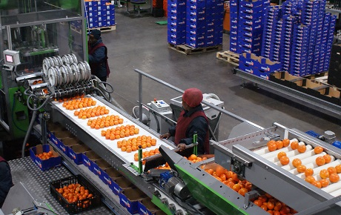

For more information:
Josef Malan
Naranja Packers
Email: josef@naranja.co.za
https://www.anbinvestments.co.za/

Publication date: 8/22/2018
Author: Carolize Jansen
Copyright: www.freshplaza.com

