Fresh Plaza – 9th April 2021

700 refrigerated containers arriving in South Africa
Maersk Vallvik arriving in Durban, South Africa with over 700 refrigerated containers to support the upcoming citrus season and customers’ needs, providing fresh fruit to various markets around the world.
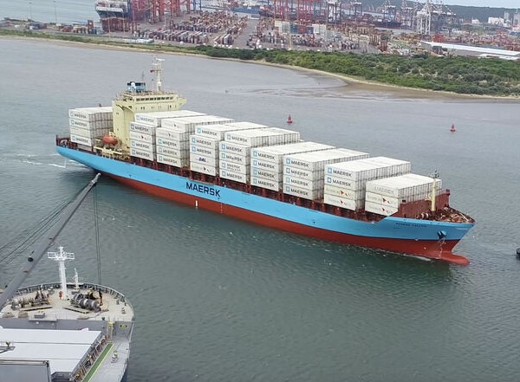
"Phasing into our AMEX (America – South Africa) service, Maersk Vallvik repositioned empty reefers from the Middle East into South Africa, as part of the continuous cargo flow plan that is in place to ensure we serve our customers throughout the year to cover all fruit seasons."
Source: linkedin
Publication date: Fri 9 Apr 2021

