Fresh Plaza – 13th May 2019

Lower Midknight Valencia volumes could point to strong mid and late orange season

Lemon season late, but good growing conditions in Sundays River Valley
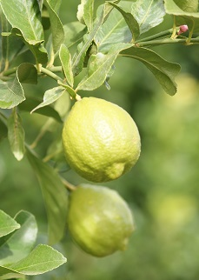Fantastic rain has fallen in the Eastern Cape’s Sundays River Valley, the best they’ve had since 2011, says Hannes de Waal, managing director of the Sundays River Valley Citrus Company.
The lemon harvest is about three weeks late - SRCC producers have harvested only about 3% so far - in part because of the rain, but even without rain disruption, they would have had to wait on colour.
“Markets have become very sensitive to colour since there are more lemons available worldwide,” he explains. “Just three, four years ago it was different. Now we hold back and try to put very good colour in the box. Fortunately we’ve had some nice cold weather and colour has started kicking in.”
“Sizing on our lemons has been hampered during the last few dry years, fruit just didn’t get as large as they could, but the rain we’ve been having could change that. Larger calibres would take pressure off a small fruit market like the Middle East. In a month’s time we’ll know for sure, but the current conditions are very good for our lemons.”
And the slow start to the campaign is no bad thing either, he says, given the full European market, but by weeks 26 or 27, he expects the European market to enter into other conditions.
Global orange stocks should run low at some point
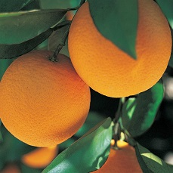Fruit set on Midknights is lower than expected and if Midknights from the north of the country are also down, especially from areas experiencing drought, it could turn out to be a very good orange year.
“I expect that the season will play out well. At some point or the other the world should be running out of oranges, and the longer the season goes on, the higher demand should climb.”
He notes that the Northern summer holidays some years complicate the South African citrus campaign in Europe (and North America), but they’re heartened by a continued rise in global lemon consumption, buoyed by healthy living trends.
The labour unrest of May last year in the Sundays River Valley is not expected to recur this season. Citrus producers have remained in dialogue with community leaders and organised labour to address concerns and keep communication channels open.
For more information:
Hannes de Waal
Sundays River Citrus Company
Tel: 27 42 233 0320
Email: hdewaal@srcc.co.za
https://www.srcc.co.za/

Publication date: 5/13/2019
Author: Carolize Jansen
© FreshPlaza.com

